Mrs Wright’s Update!

As we come to the end of another busy and fruitful half term at The Cathedral School of St Mary, I want to take this opportunity to reflect on our achievements and share some important reminders.

Celebrating Success
Our students have continued to impress with their dedication, enthusiasm and talents. Highlights this half term include:
- Academic Excellence: We are very proud of how our pupils are adjusting to the increased home reading expectations this year. In order for our pupils to fulfil their potential it is essential that they dedicate time to reading at home and at school. Our school expectations are that every child reads at least four times a week to an adult at home and that their reading record is signed. Education is a three way relationship between home, school and the child and so it is vital that we as parents support our children with this at home. If your child is reluctant to read at home please share this with the class teacher and we can work together to enable this to happen.
- Sports Achievements: This half term all classes have been receiving weekly cricket coaching from a member of Plymouth Cricket Club. The children have thoroughly enjoyed this and the coach has encouraged the children to try cricket out of school. Mr Parker and myself took a Cross Country team from CSOSM and St Joseph’s to Staddiscombe last week. This was our first joint journey in our new minibus with me as the driver! The children conducted themselves brilliantly and were great ambassadors for our schools.
- Events: Miss Galloghly’s class are taking part in the ‘Sea in our School’ project which is the flagship education programme for the Plymouth Sound National Marine Park. The children will take part in activities that are curriculum linked, with a focus on engaging and connecting school children with the National Marine Park. To launch the project the class visited the Aquarium. Our Foundation class attended a Teddy Bears’ Picnic as part of our Widening Horizons project. Mrs Berry’s class were the first to travel in the new minibus to the Tamar Bridge as part of their History topic. Mr Davies’ class took part in the Kier Construction community storytelling and book gifting project.
- Faith in Action: As a Catholic school, our faith is at the heart of everything we do. Each week a class attended Mass at the Cathedral and this week years 1-6 attended a special Harvest Mass with the community. On the last day of half term we celebrated the 10 year anniversary of CAST (our Multi Academy Trust) with a Mufti day. The money raised by this event will be donated to the Catholic Children’s charity.
I’m delighted to announce that our attendance data has improved from this time last year. Thank you for the support you are giving to ensure that your children attend school every day. Please remember to send your child in even if they are not 100%. We will always call you if they need to go home. We will continue to monitor attendance closely this year and we can arrange meetings with families to see how we can work together to remove any barriers hindering attendance.
Please take note of the guidance regarding term time holidays and unauthorised absences within this newsletter. School cannot authorise term time holidays and 10 absences (5 school days) will result in a fine from Plymouth City Council.
To finish, I would like to thank our dedicated staff, supportive parents and carers and most importantly, our wonderful children for making our School of Joy such a vibrant and caring place to learn. Let us continue to work together to foster a community of faith, learning, and love.
God bless
Mrs R Wright


Catholic Life and Events

Catholic Life  This half term has been an incredibly busy half term for us at the Cathedral School. Our Catholic Life is flourishing thanks to our staff, pupils, clergy and to you the wonderful families. This half term, we welcome a full GIFT chaplaincy team who applied for the position of chaplain and were celebrated during a Friday celebration assembly for their roles.  Our GIFT Team have continued to be beacons of light in our school, guiding our faith at the Cathedral. The chaplaincy team have led their first Monday Liturgy which was highly commended by our CAST trusts’ Chief Executive Officer, Mrs Zoe Batten. Well done to the GIFT team!  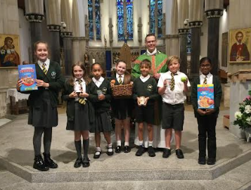  Finally, we celebrated a beautiful end of half term Harvest Mass. We are truly blessed to have such an incredibly supportive school community with the vast amount of generous donations for the Plymouth Foodbank. A huge thank you to you all!  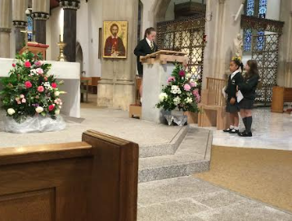 |  | Regular events in The Cathedral Centre  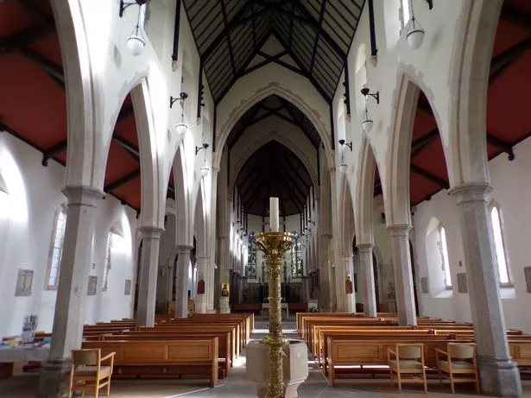  Ecumenical Bible Study Group:  Thursdays -10.00am coffee/tea, 10.30-11.30am.  Legion of Mary:  Thursday, 6.00pm to 7.30pm  Union of Catholic Mothers:  Tuesdays 1.30pm-3.30pm.  St Pio Prayer Group:  On the first Friday of every month after 7.00pm Mass, all are welcome. Contact: Rev. Deacon Tony Irwin, Tel. 01548 853413.  Society for the Protection of Unborn Children:  Meet in the Cathedral Centre, third Wednesday of every month at 7.30pm. Contact Christine Hudson Tel. 01752 224018.  Knights of St Columba:  Every second Monday of the month at 6.30pm.  The Cathedral Centre Events
Congratulations!

  We have high expectations for all of our pupils to arrive at school each day and on time. Thank you for your continued support.  The highest attendance this half term goes to…    Miss Galloghly’s class  As a ‘well done’ for winning this half term’s attendance, your class have earnt an extra 20 minutes playtime- keep up the excellent work! |  |   Heart of Gold Awards  Miss Grosch’s Class  The heart of gold this week goes to all the foundation children in my class. They have had an amazing half term settling into school life. It’s such a big change, but they have all faced that change with a great attitude (most of the time!!) I am so happy to have them in school and am excited to see them grow in their first year of school!  Mr Davies’ class  The Heart of Gold winner this week goes to Aurora for her wonderful kind hearted nature and enthusiasm in her learning. Aurora has settled in so well to our school and shown all of the Gospel virtues. She has worked particularly hard this half term with her writing and has made superb progress. Aurora keep shining and showing off your wonderful personality. Well done you superstar!  Miss Galloghly’s Class-  The Heart of Gold winner is being awarded to Omotola. Omotola was a new beginner at our school this term and she has settled in beautifully, showing an amazing attitude to her learning and our ready, respectful and safe behaviours at all times.  Mrs Berry’s Class-  Tony has a great attitude to learning and never gives up. He can be relied upon to work well in a group and independently. When faced with challenges, Tony perseveres and always tries his best, asking for help when he needs it. Furthermore, Tony never fails to make everyone he meets smile. Well done Tony!
  Miss Grosch | 95.33%
  Mr Davies | 93.31%
  Miss Galloghly | 95.57%
  Mrs Berry | 93.59%

News and Events

Meet the Staff    Mrs Laidlaw  Earlier this year I started volunteering at Cathedral School and started a TA's course. Since joining the team at CSOSM I have felt welcomed and enjoy supporting the development and education of the students there. I have a teenage son and daughter who used to attend CSOSM. My hobbies and interests are history, science, arts and crafts, (drawing, painting, cross stitch). I like watching films too. I help out with the children's liturgy and the Meet and Make group at the Cathedral. |   Meet the Staff  Mrs Demellweek    In my spare time I spend time with my husband and our children, we watch our son play football and take our little girl to ballet. Our son, Finley, is almost 16 and our daughter, Sophia, is almost 2.  I like running as a hobby and have completed the Plymouth half marathon, it was not easy to say the least! I often take part in the Midnight Walk for St Luke's.  I love going out for meals with my friends, especially a bottomless brunch! | Meet the Staff  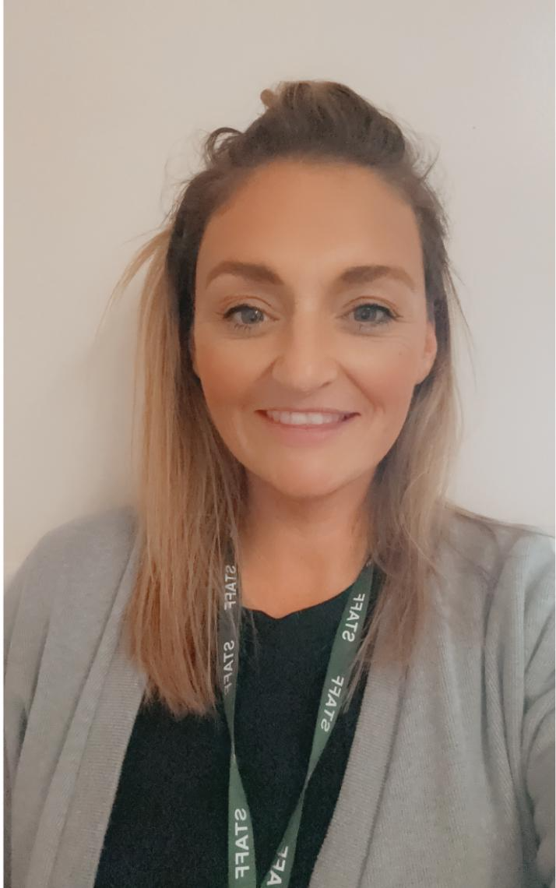  Mrs Scott  My name is Mrs Scott and I am really looking forward to working alongside Miss Grosch and the children in her class. I am a mum of four so being around children is second nature to me. I enjoy listening to music and spending time with my family. I am looking forward to working alongside the children of The Cathedral School of St Mary and ensuring that they continue to grow and flourish as they embark on their school journey.


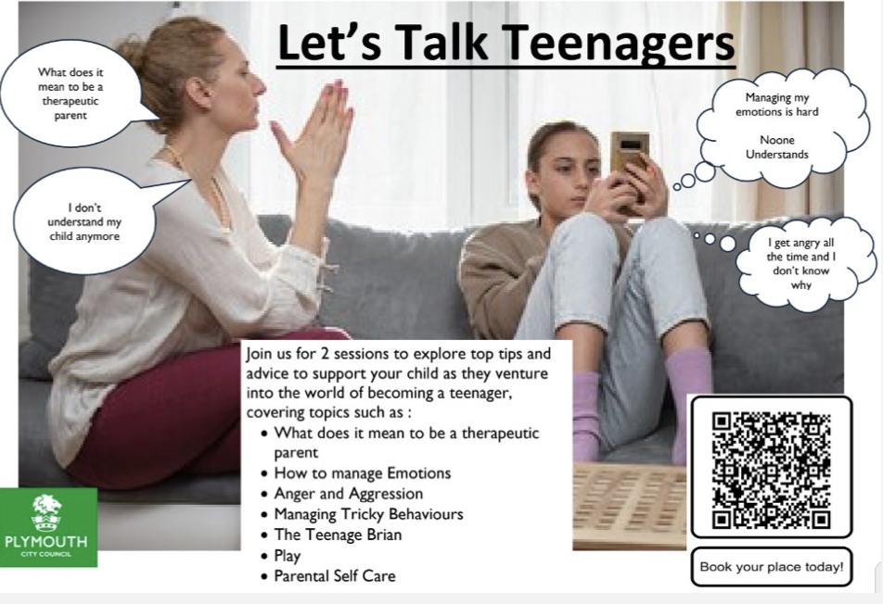
Let’s get talking at home!

We Love To Learn!

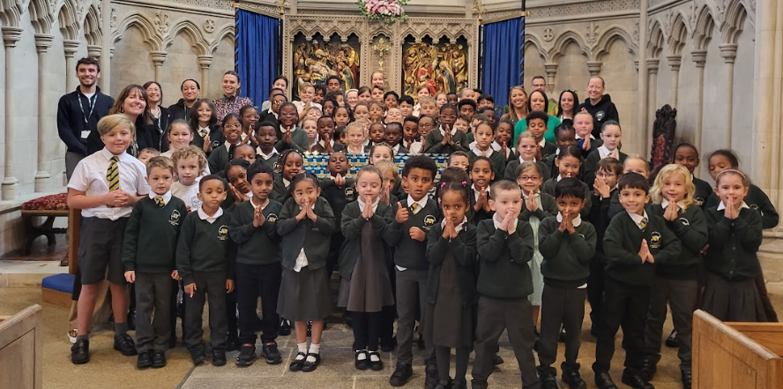 |  | 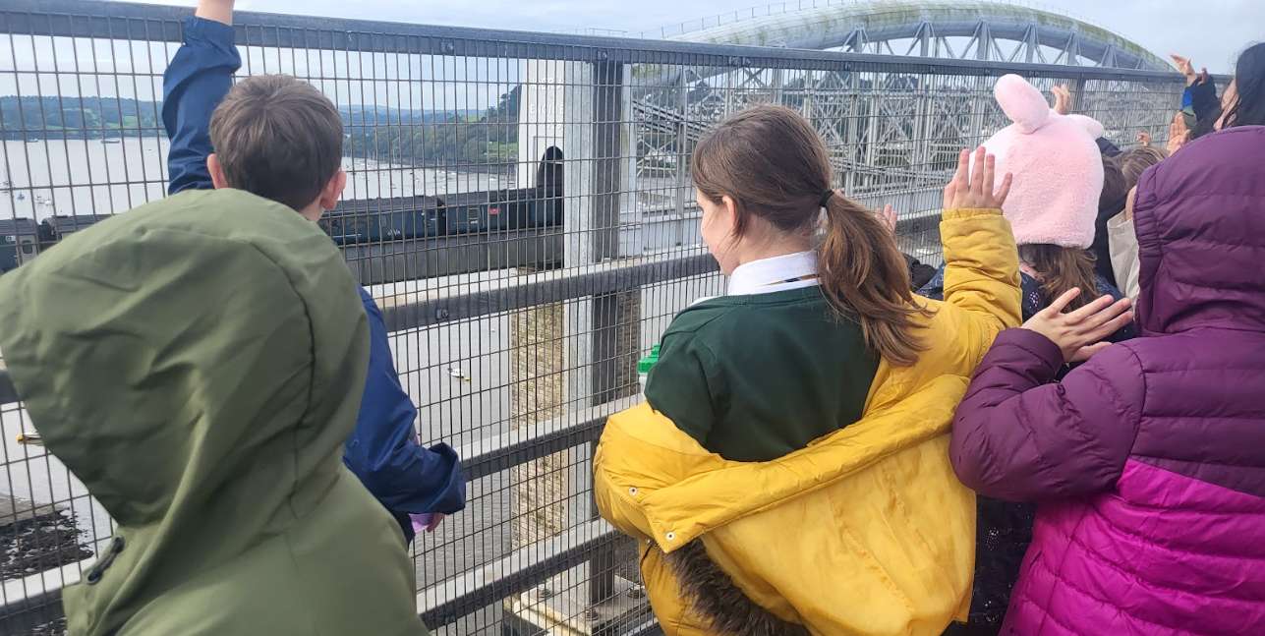
We started our school year as we always do with a beautiful Mass led by Canon Mark. |  | Mrs Berry’s class enjoyed a visit to the Royal Albert Bridge to support the learning they have been doing about Isambard Kingdom Brunel.
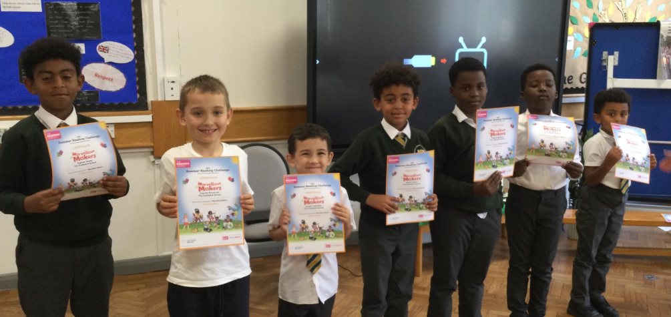 |  | 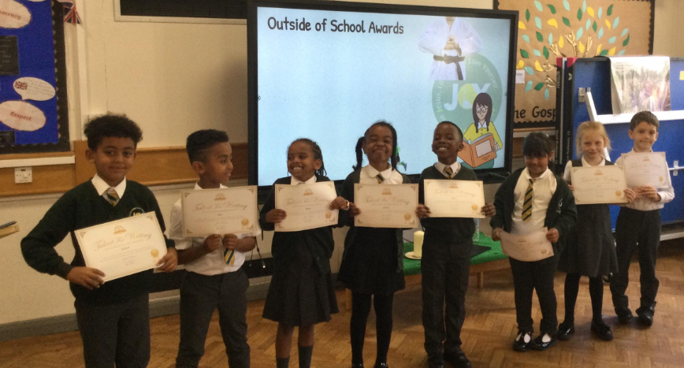
Austen visited from the Central Library to award those children who completed the Summer Reading Challenge. |  | Some of our wonderful year 3 children found out they are going to be published in a book after entering a competition last year. .
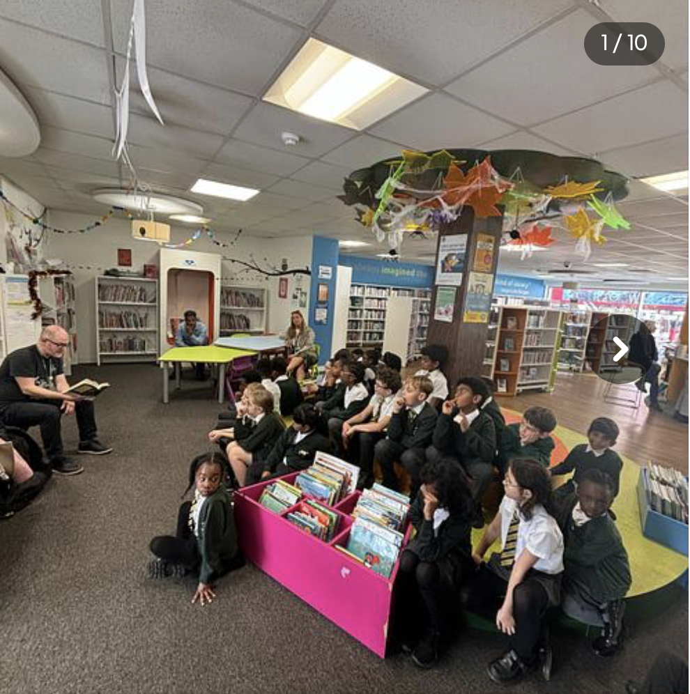 |  | 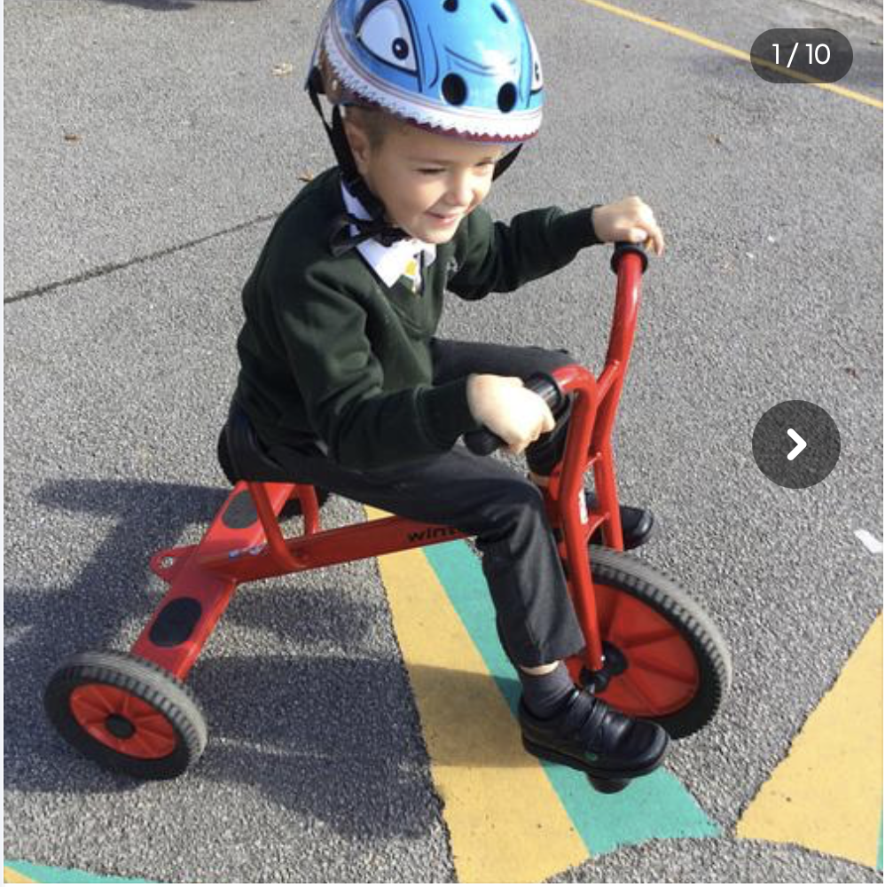
The children have continued to visit the library on a regular basis to continue to develop a love of reading! |  | In EYFS, we have been using the bikes and trikes whilst making the most of the sunny autumn weather.

Get Involved!

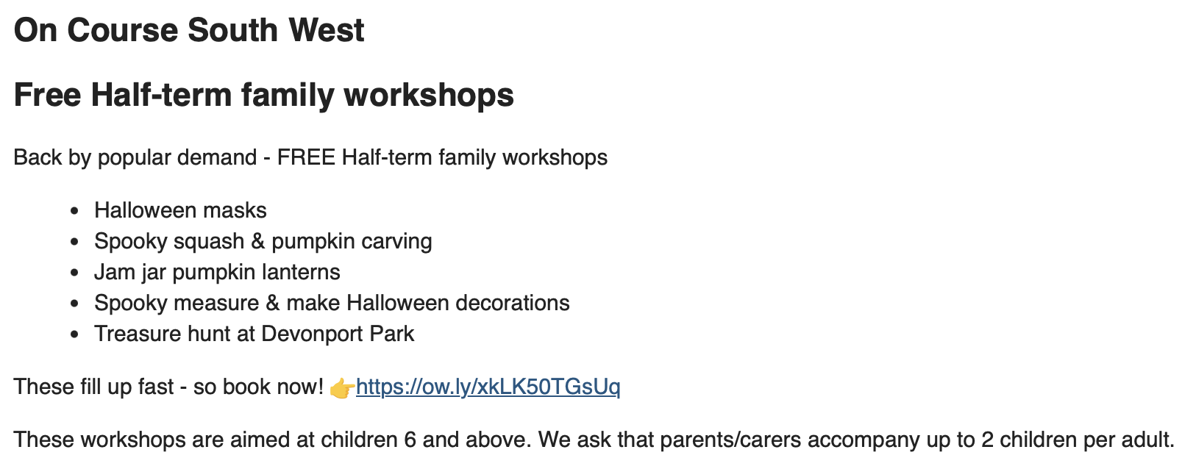
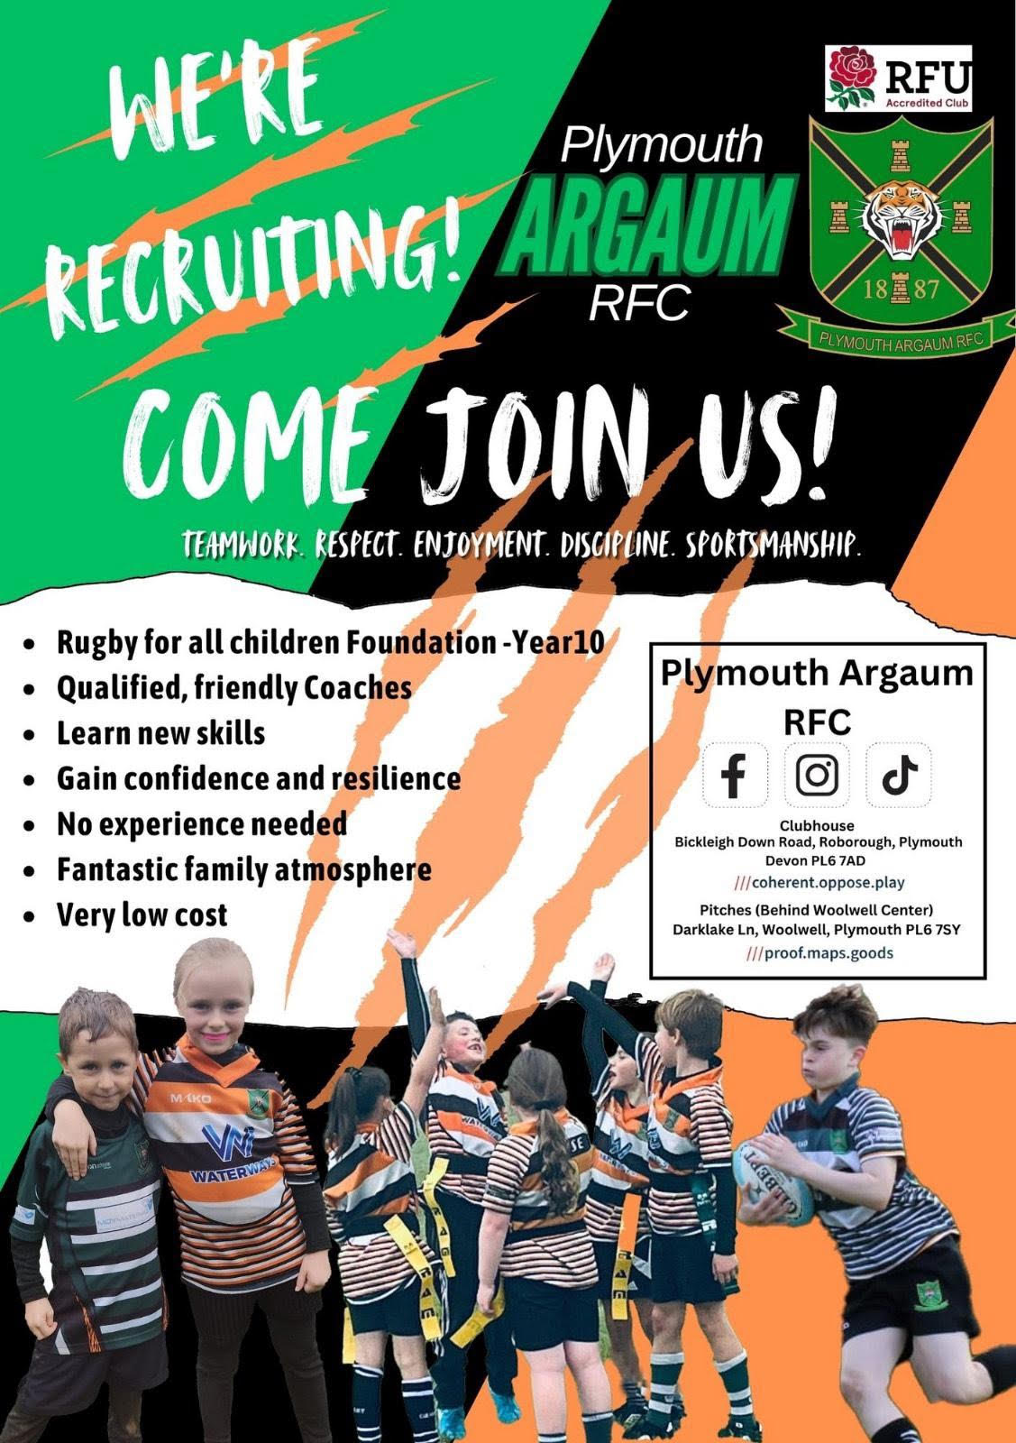

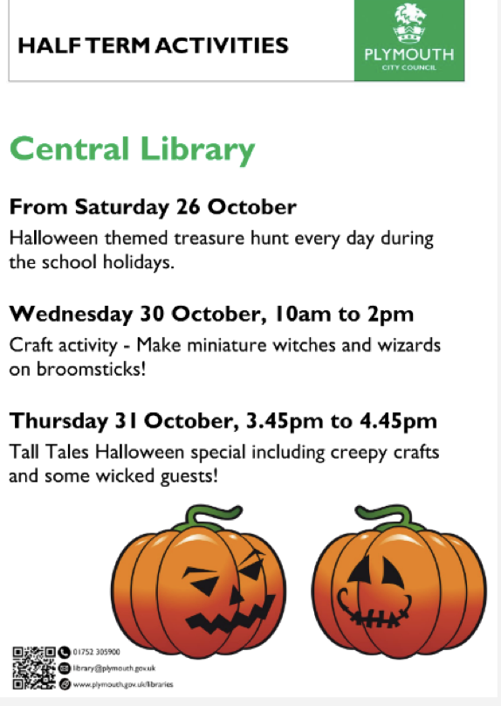

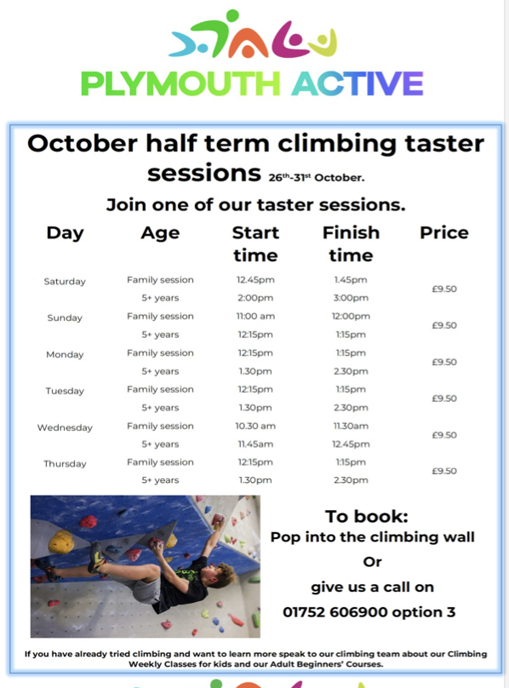

Advice and Support

We are Readers

Miss Galloghly’s class have been reading ‘Escape from Pompeii’ by Christina Balit.
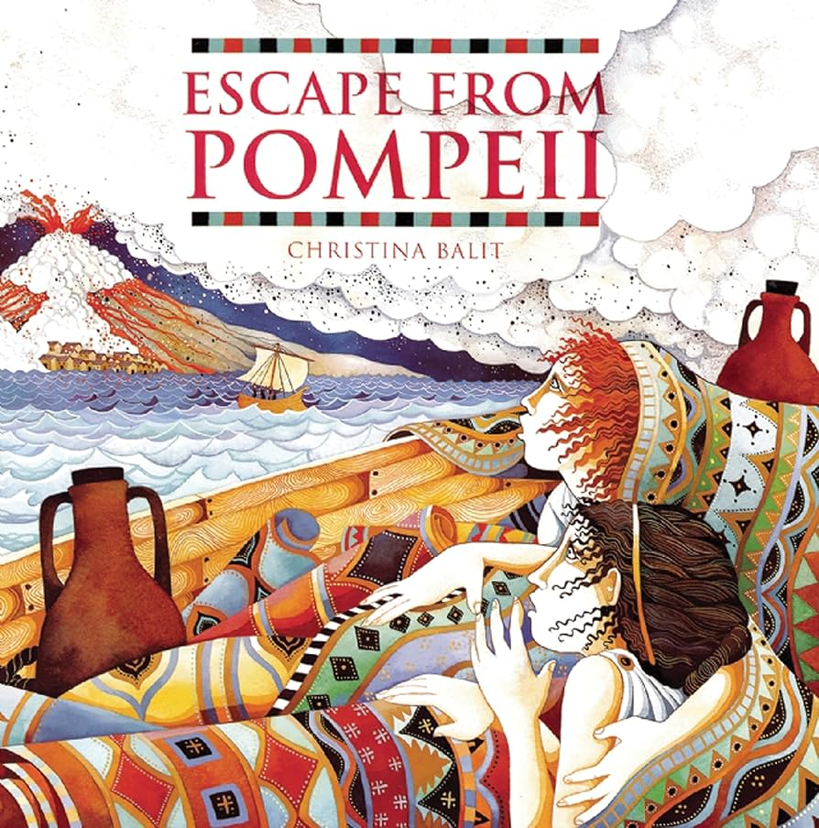
The children have loved making predictions on what they believe will happen next, as well as learning all about the historic event of Mount Vesuvius erupting through the eyes of the main character,Tranio.
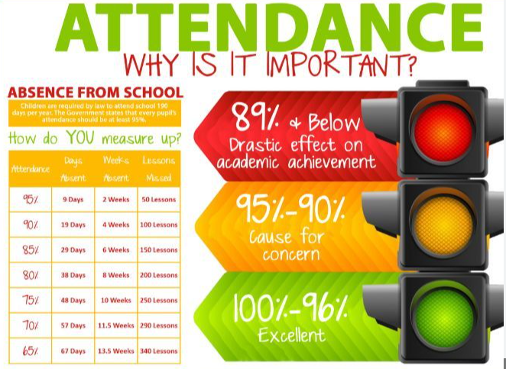
Attendance update
Attendance update

As a school, we are delighted with the improvements we have made with our attendance so far this year.

2024-2025 Attendance Update

School- 94.1%
National- 95.8%
Local Authority- 95.5%

Previous year attendance 2023-2024

School- 93.6%

……………………………………………………………………………

One area we are keen to address are those children and families who are persistently absent (Less than 90% attendance).

Unless your child is considered medically unwell, please make all reasonable attempts to bring them into school. If your child is unwell in school, we will inform parents to collect their child.

Dates for your diary  Monday 4th November - non pupil day  Tuesday 5th November - Children return to school.  Wednesday 6th November - Parents Evening  Thursday 7th November - Parents Evening  Tuesday 19th November - Ready, Steady, Read! Session at 2 pm.  Wednesday 18th December - carol concert at the cathedral.  Friday 20th December - last day of term  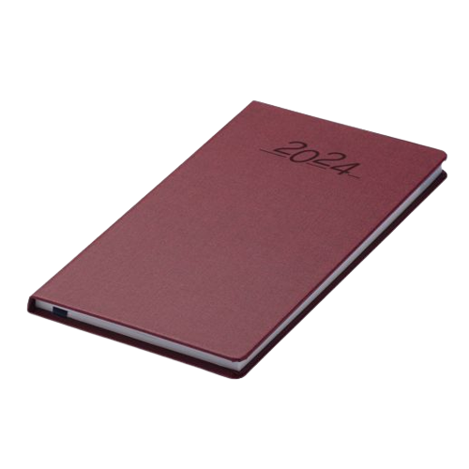 |  |   The uniform store Plymouth is a free service for families to kit out their children for school.  Through donations of good quality school uniform, we give the items to those in need, free of charge.  Our service is open to anyone to use- no referral is needed.  We are located at;  93 New George Street, Plymouth City Centre, PL1 1RQ  Opening hours:  Tuesday, Wednesday and Friday 10am-1pm.  Plymouth Uniform store


Is your child eligible for free school meals?

If you receive certain benefits then your child may be entitled to a free school meal and if so, their school receives extra funding. This means it’s important to apply, even if your child is in reception, year 1 or year 2 and already receives a free lunch.

Check the criteria and apply online: Free School Meals Plymouth

FOOD REQUEST

The Cathedral School of St Mary

have teamed up with

Love in action group -

The Cathedral Church of St Mary and St Boniface

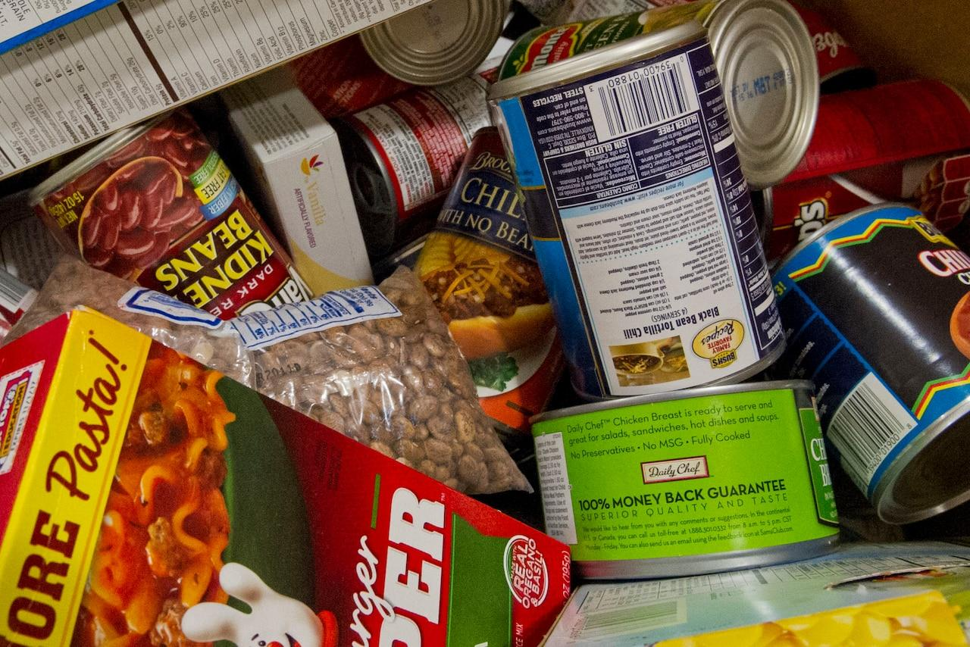
If you email Marianne our School PSA, by Tuesday 2pm of the week you require help with food, you will be able to collect from School on The Wednesday/Thursday

t.cook@plymouthcast.com#

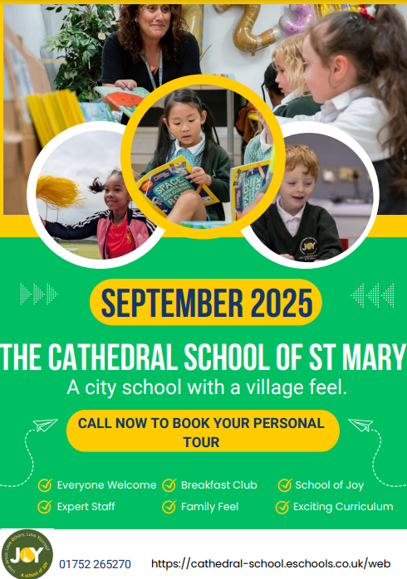
Spaces Available For Foundation September 2025!

