Mrs Wright’s Update!

Dear Parents and Guardians,
As we approach the end of another academic year, I wanted to take a moment to reflect on our collective journey, celebrate our successes, and look forward to the summer holiday.
This year has been filled with remarkable achievements and growth for our children. From academic milestones to personal development, our children have demonstrated resilience, creativity, and a love for learning. Our focus on fostering a supportive and inclusive environment has enabled every child to thrive, and the progress we've seen is truly inspiring.
One of the highlights of this year has been our various school projects and events. The Y5 Widening Horizons scheme of learning has provided our children with opportunities to develop positive career aspirations. Our school community also came together for a truly magnificent sports week, lead by Mr Driscoll, and our children had many sporting opportunities they would not ordinarily have had such as horse riding and indoor climbing. Additionally, our sports teams have shown great spirit and sportsmanship in numerous competitions with a highlight being our 5/6 football team taking part in numerous competitions and winning their most recent competitive football event. These activities have not only enriched our curriculum but also helped in building a strong sense of community and collaboration among our children.
Our dedicated teachers and staff have worked tirelessly to provide high-quality education and support to our children. Their commitment and passion for teaching are evident in the positive outcomes we see every day. I would also like to extend my gratitude to all parents and guardians for your unwavering support and involvement in school activities. Your partnership is vital in creating a nurturing environment for our students.
As we prepare for the summer holiday, I encourage everyone to take this time to relax, rejuvenate, and enjoy quality moments with family and friends. Summer is an excellent opportunity for children to explore new interests, read for pleasure, and spend time outdoors. While it's important to rest, engaging in fun, educational activities can keep young minds active and curious.
Finally, I want to take this opportunity to thank the school community for the support they have given me as the new Headteacher this year. I have enjoyed getting to know the children and families at both schools and look forward, after a holiday, to the next academic year.
I wish you all a happy, healthy summer break.
God Bless
Mrs R wright

Catholic Life and Events

Catholic Life  As we come to the end of another wonderful year, we have had many opportunities to celebrate and be thankful for the gifts we have been given.  Several of our liturgies have focused on how the children can give more of themselves in support of their friends.  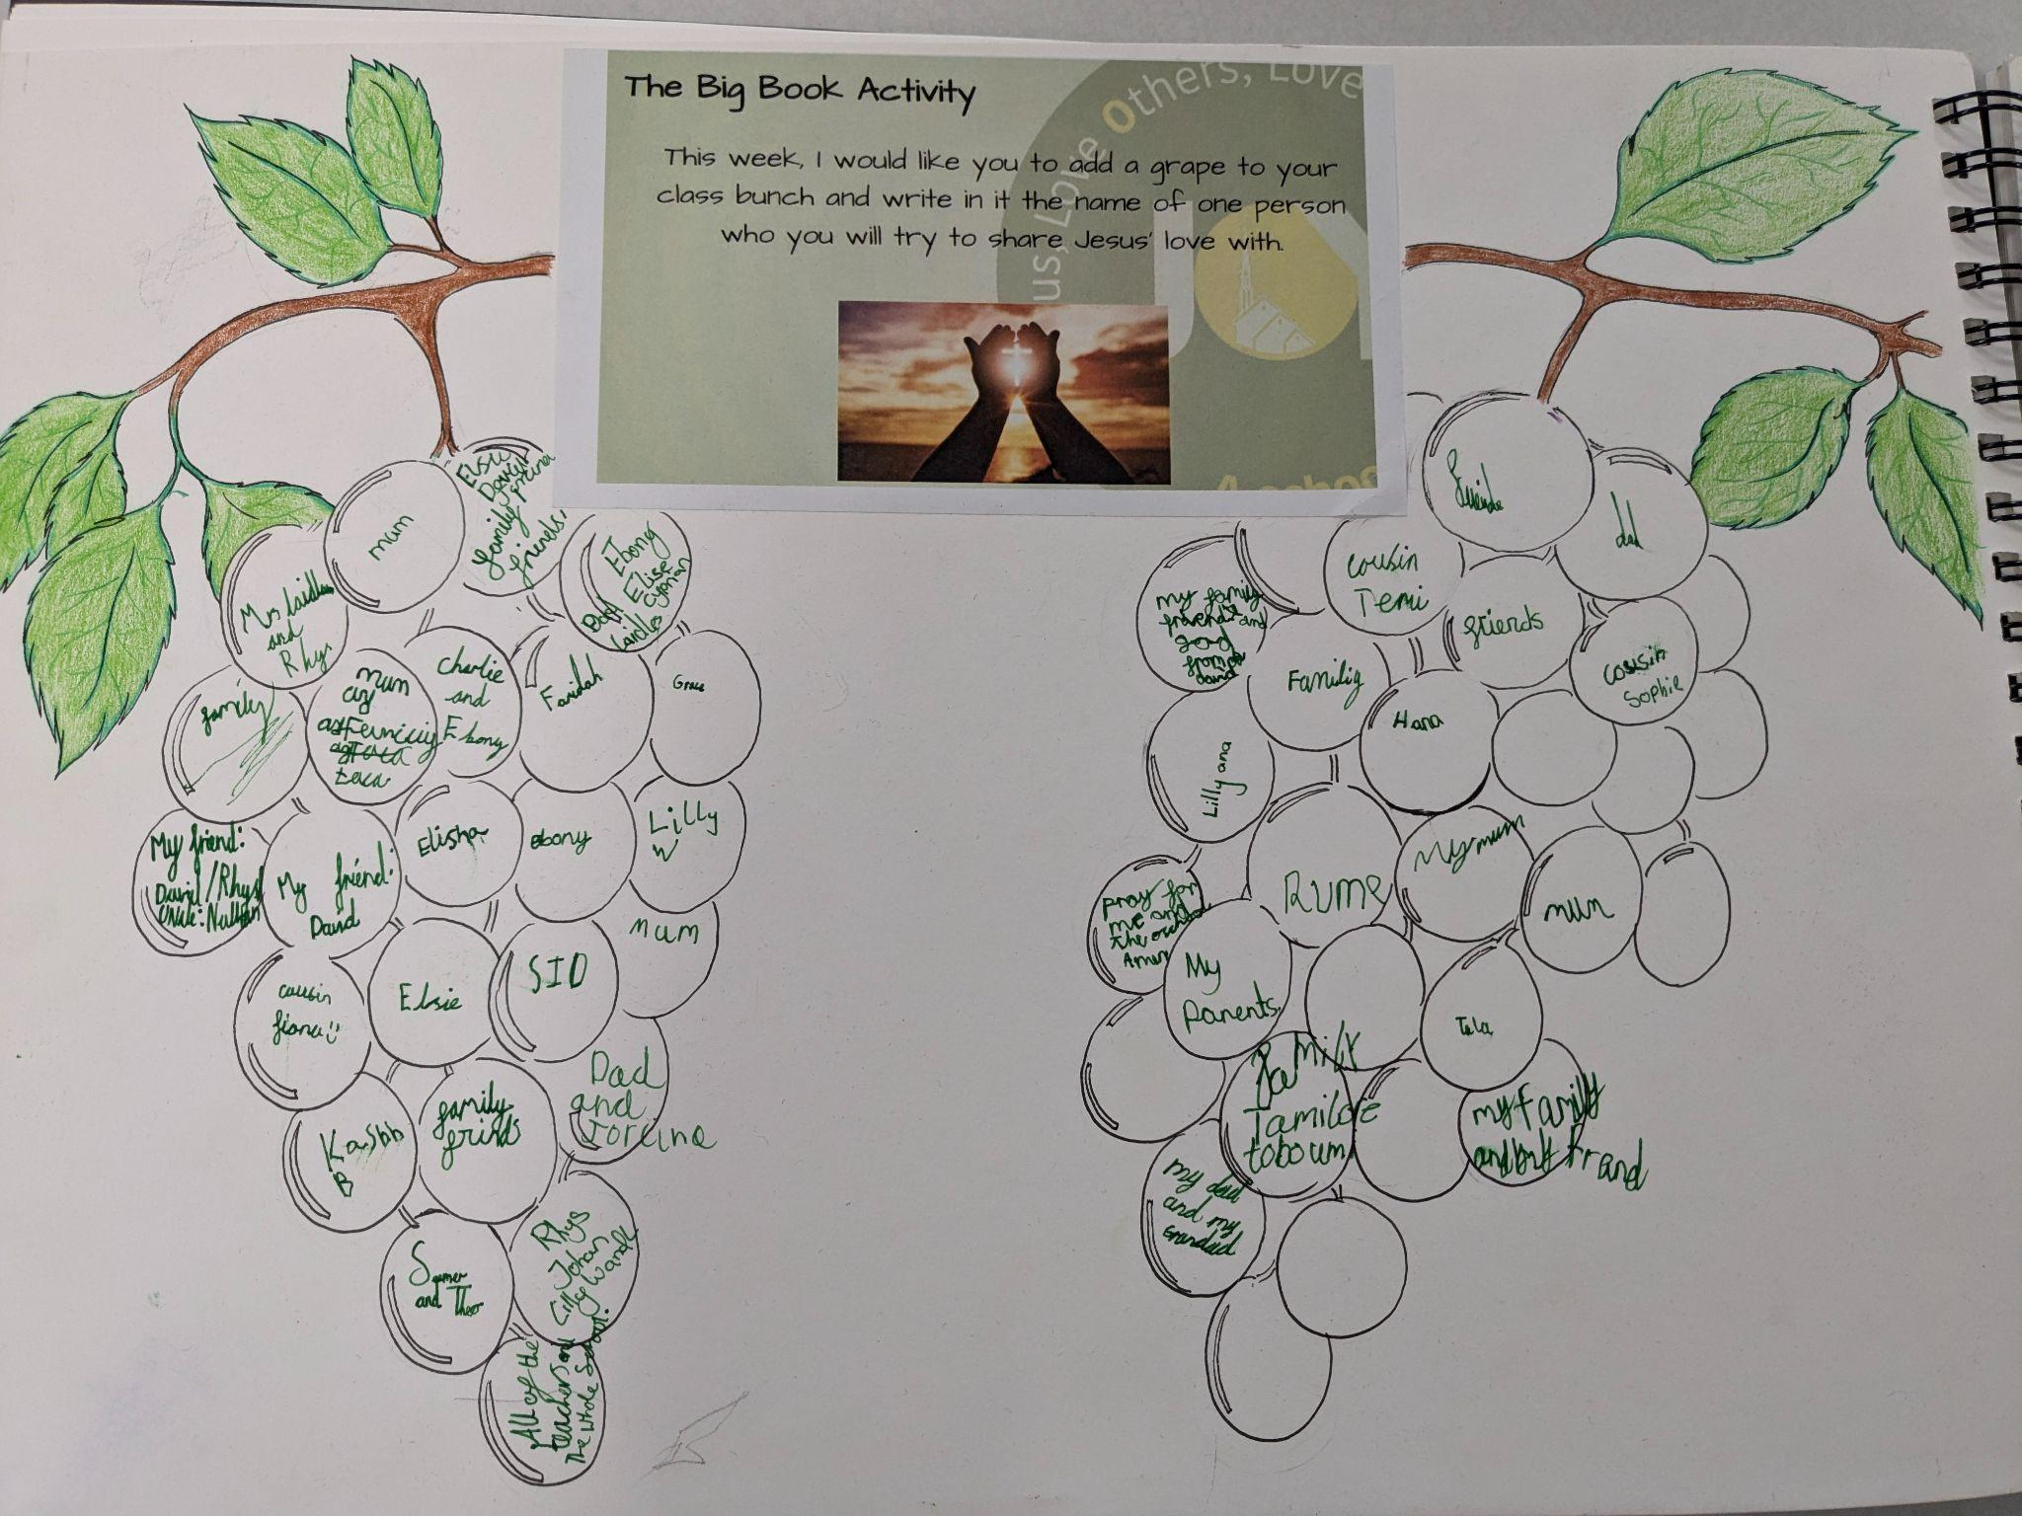  We always give ourselves time to listen to, and act on God’s words for us and we try to note these down in our Big Books.  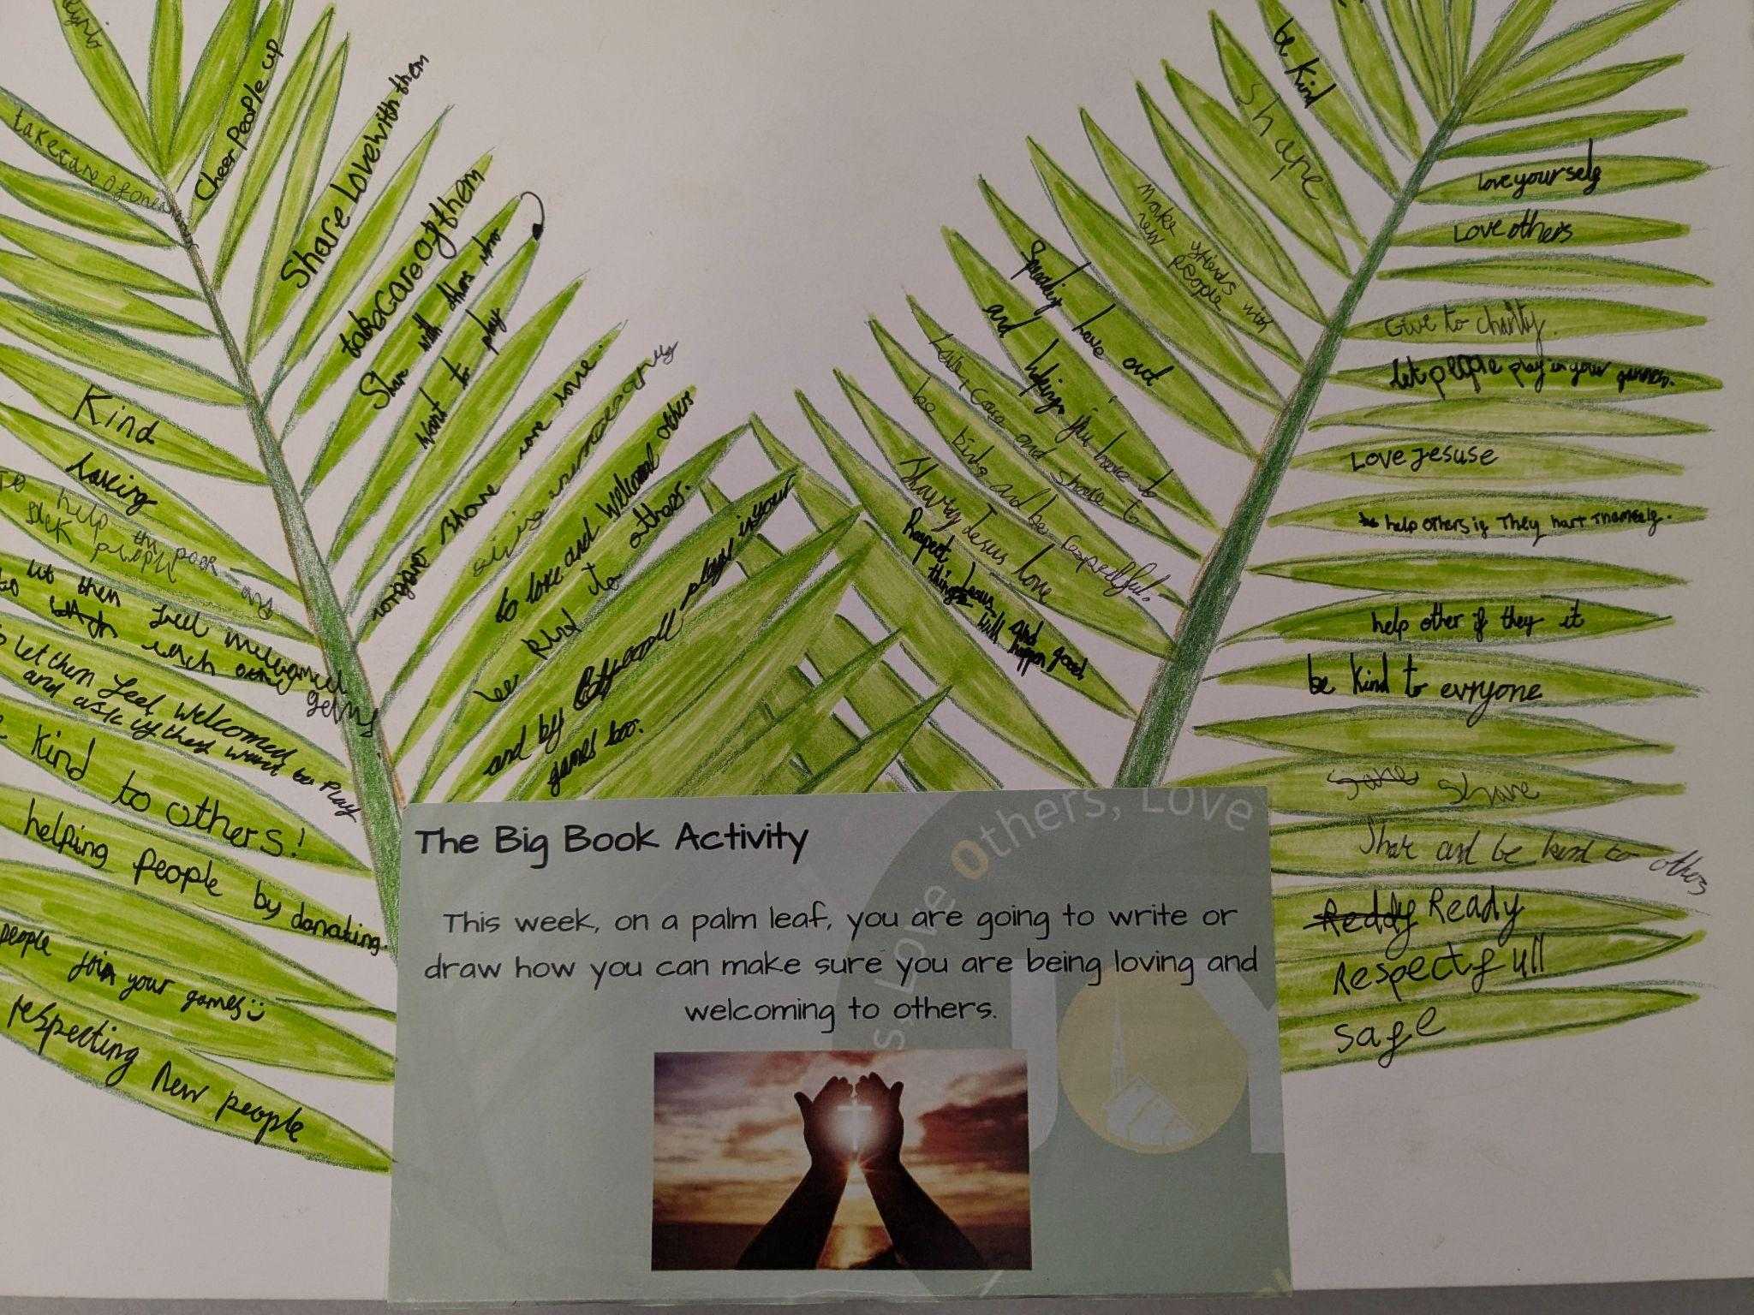  The children have spent time reflecting on what it means to be a friend and how this can sometimes mean knowing when to help a friend through a difficult time, or make a difficult decision.  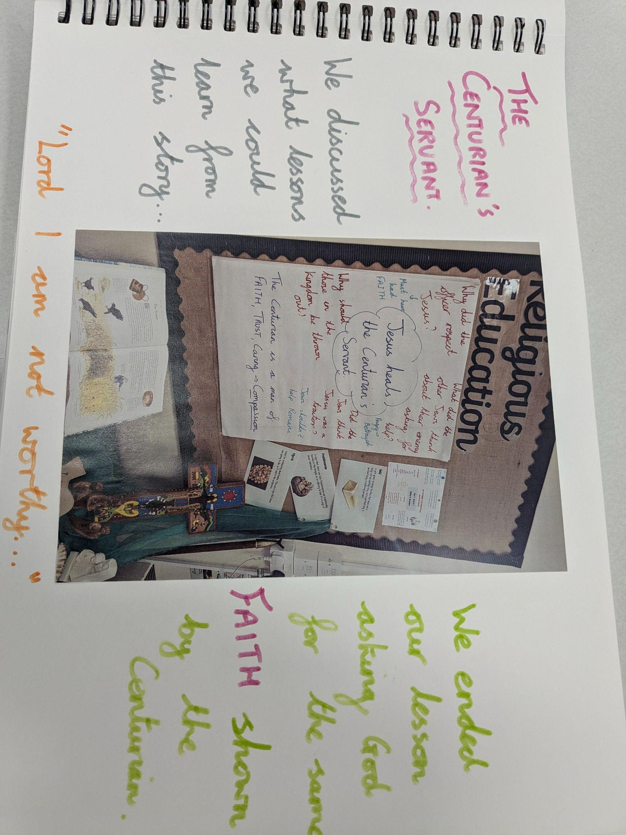  We also spend time thinking about the changes we need to make in ourselves to ensure that we are being God’s hands on Earth. |  | Collective Worship  Our Class Masses have continued this term with each class joining Canon Mark and the local parishioners in prayer at the Cathedral.  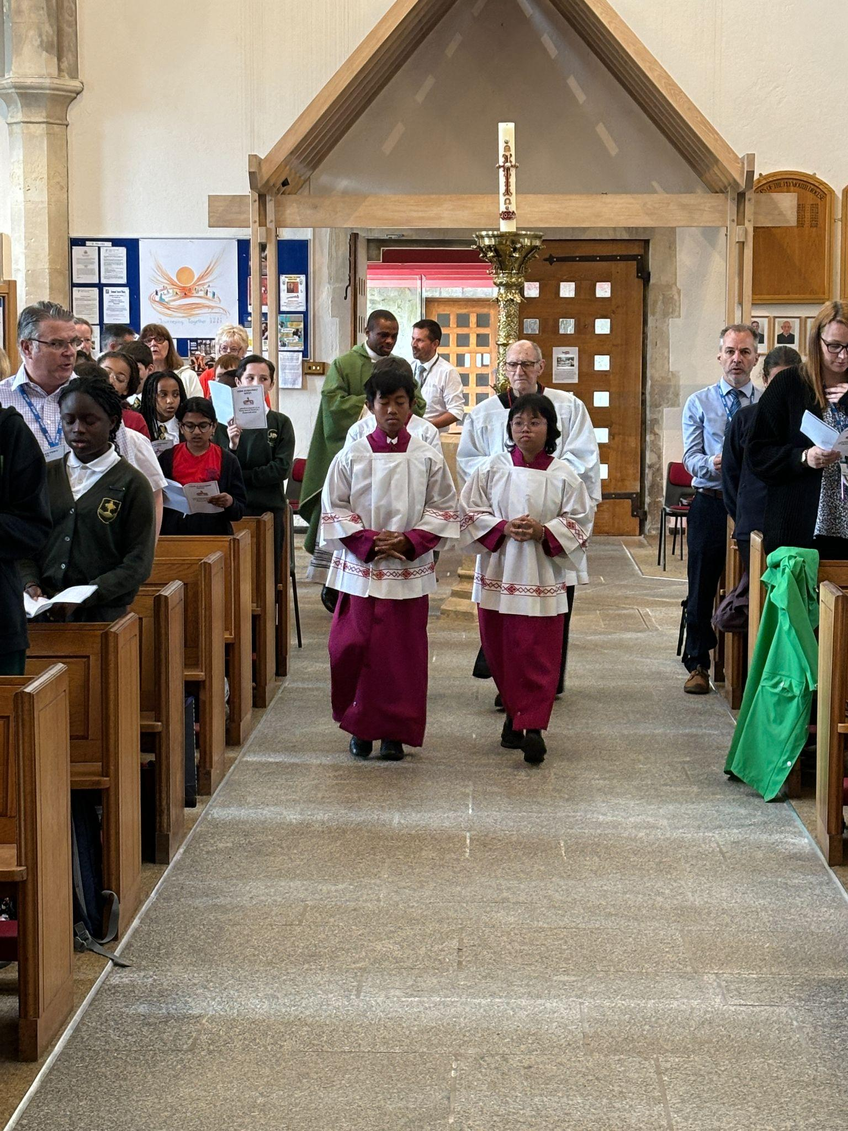  Our Year 6 children were invited to join together with several other Plymouth CAST schools in their Diocesan Leavers Mass.  During the Mass, the children prayed for God’s love and guidance as they prepare to move to their new schools in September.  Several of the children represented the school through their readings, the giving of gifts and serving on the altar. They also joined in with a very engaging version of ‘My Lighthouse’!  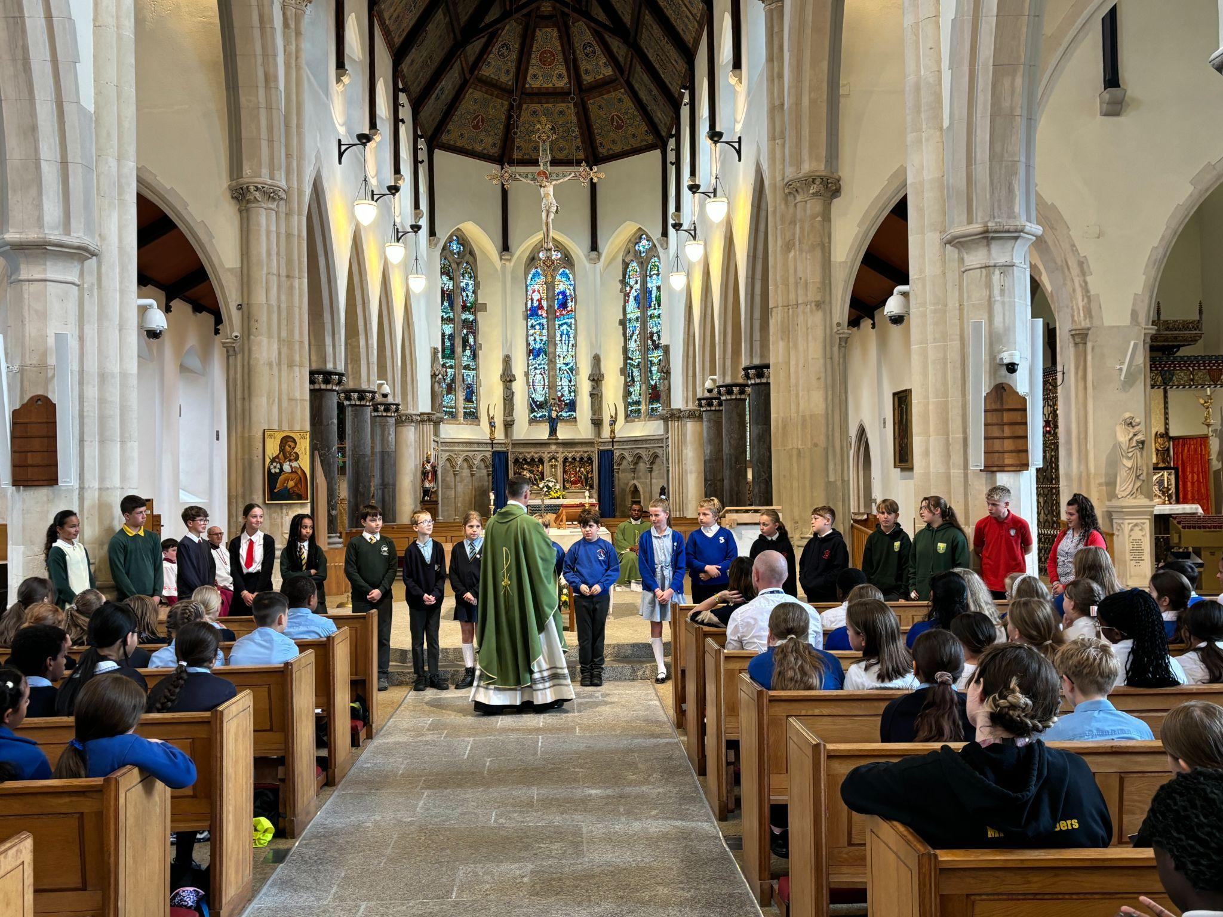  We will continue to pray for our Year 6 children and all of our school family.
Congratulations!

  We have high expectations for all of our pupils to arrive at school each day and on time. Thank you for your continued support.  The highest attendance this half term goes to…    Mr Driscoll’s class  As a ‘well done’ for winning this half term’s attendance, your class have earnt an extra 20 minutes playtime- keep up the excellent work! |  |   Heart of Gold Awards  Miss Grosch’s Class  The heart of gold this week goes to Chase. Chase is someone who could get this most weeks. He is always wanting to share his experiences and ideas with the class. He shows our school rule of being respectful always, in his interactions with both adults in the class, and his peers. It’s been a pleasure to teach him this year - well done Chase!  Miss Galloghly’s Class-  The Heart of Gold winner this week goes to Hana. Hana never fails to put a smile on both my face, and all of her peers. She is a joy to have in the classroom: always helping and supporting and trying her best in all that she does! Well done Hana.  Miss Toms’ Class-  The Heart of Gold award this week goes to Olivia for her constant caring and supporting of others. She is such a joy to be around and she has the biggest heart. Olivia is so loving and nothing is ever too much trouble for her. She always has a smile on her face and I know that she will flourish in year 2, just by being her kind-hearted self. Well done Olivia.  Mr Driscoll’s Class-  Jorcina and Ebony have both been awarded the Heart of Gold Award this week for their fantastic support and constant desire to help others. Both girls have embraced their roles as GIFT Team members this term and are exemplary models for their peers. Well done and thank you girls!  Mrs Berry’s Class-  Lena has been a dream to teach all year. She works very hard, is always looking for ways to further her learning and concentrates well in class. Lena can be quiet and conscientious when needed and shows her brilliant sense of humour when given the opportunity. Well done on a fantastic year Lena!
  Miss Grosch | 93.33%
  Miss Galloghly | 90.59%
  Miss Toms | 87.14%
  Mr Driscoll | 93.94%
  Mrs Berry | 86.97%
News and Events

Meet the Staff    Mrs Laidlaw  Hello , my name is Kerryanne Laidlaw. I am very excited to start my new role as a Teaching Assistant; joining the team at CSOSM.  I have two children who attended CSOSM many years ago. They enjoyed their time at Cathedral and are now thriving at their secondary schools doing their GCSEs and A levels. My eldest has recently become Head Student at his school and has already achieved a place at Exeter University . My daughter is at Notre Dame and has the role of Peer Mentor and a YSL( Young Spiritual Leader). Outside of the school environment, I like to develop my skills in drawing and painting. I like to read the history of the Tudor period and I like to Cross stitch in my spare time.  I am a member of the Cathedral parish and I assist Mrs Lesley Peacock( who is one of our school's governors) in running the Children's Liturgy at Mass on Sundays. There, we already see familiar faces of CSOSM who join in the activities.  Over the past few months I have volunteered; helping the Teachers at the school, working with the children and running the after school art club. During this period I very much enjoyed this experience , contributing, supporting the children's education and personal development.  I am very much looking forward to joining the team and working with you all.  Wishing you all a splendid summer and see you in September. | Meet the Staff  Mr Davies    Hello! I am Mr Davies and I am extremely excited to be working again at the Cathedral School of St Mary’s.  I feel extremely honoured and lucky to be able to teach at the Cathedral School. I initially joined the Cathedral School in September 2021 but moved across full time to St Joseph’s in November 2021. I know from my short time how special this school is and felt the real warmth and welcome at this incredible school. I am looking forward to working alongside all the staff, Governors and you, the families.  In the past three years, I have worked at St Joseph’s and have enjoyed working across both schools for various celebrations and religious events. This year ahead I am excited to lead RE at the Cathedral school and feel honoured to work alongside our clergy once more.  I am very much looking forward to meeting you all, please come and say hello at the beginning and end of the day and feel free to come to me if you need anything.  I am very much looking forward to working with the fabulous team and working with you all. I hope you have a peaceful and hopefully sunny summer holiday and see you in September!

We Love Learning!

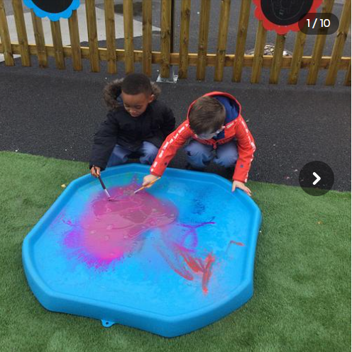 |  | 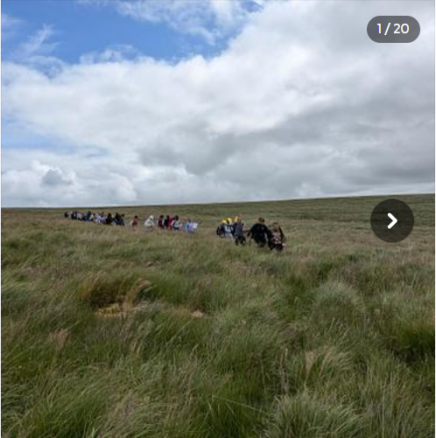
We have enjoyed working outside using puddles and powder paint to make colourful puddles! We mixed colours, added more water and even used bubbles to make bubbly paint! |  | Years 3/4 had a great time walking across Dartmoor with some of the children from St Joseph’s. We walked 5 miles and we had a fantastic day.
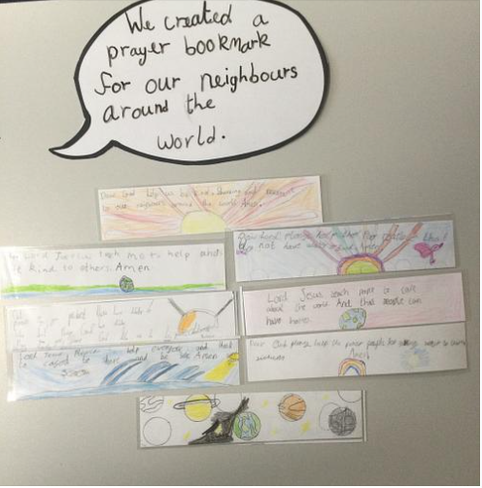 |  | 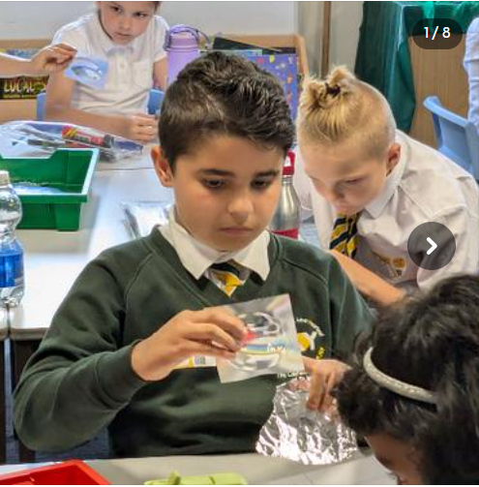
Year 2 created some beautiful bookmarks as part of their global family RE unit. |  | In science, we explored how objects reflect light in different ways. i
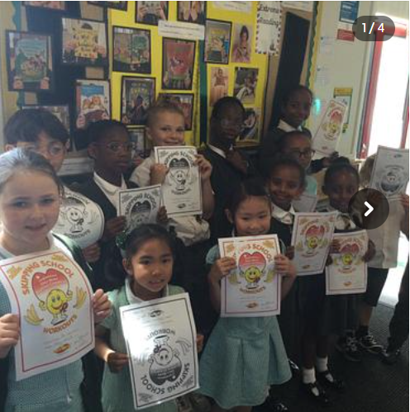 |  | 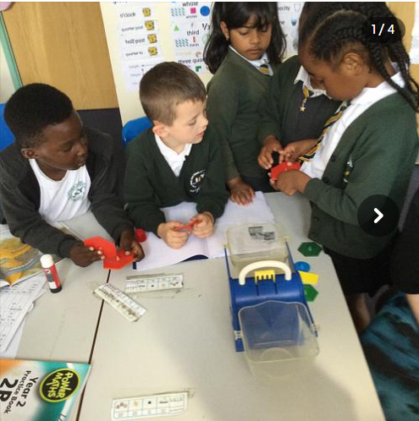
Throughout the year, lots of our children have received awards during our celebration assemblies at the end of the week. |  | We have had fun measuring amounts in different variations as part of our new maths unit. We’ve weighed grams on scales and measured ml of liquid to support our understanding of capacity and volume!
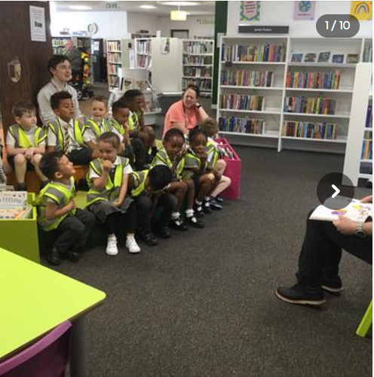 |  | 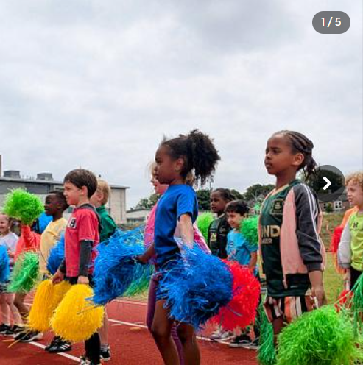
Foundation had a great time visiting the library! We really enjoyed exploring all of the books that were on offer. |  | The highlight of our summer term was our sports week which ended with sports day. We had a wonderful time- thank you Mr Driscoll for organising this for us!
Summer Events


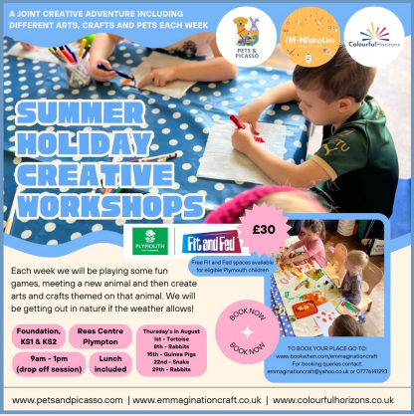

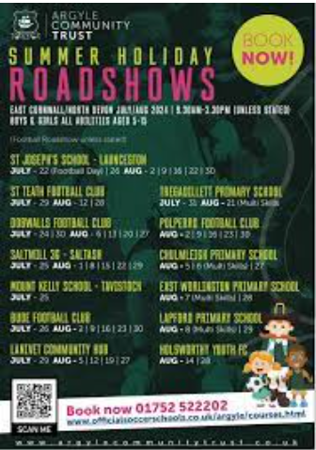
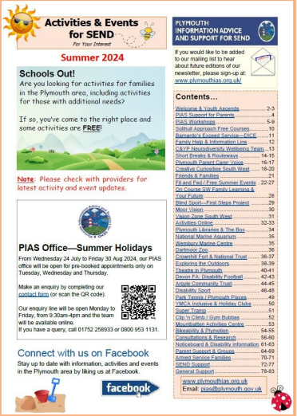

Advice and Support

We are Readers


Mrs Berry’s class has been reading ‘The Boy at the Back of the Class’ by Onjali Q Rauf. This is a beautiful story about a refugee boy who has had to flee Syria due to war. The narrator, a child who has experienced their own hardships, shows kindness and warmth to make the boy feel welcome in his new school. We recommend everyone in Key Stage 2 read this book and
others by the same author.
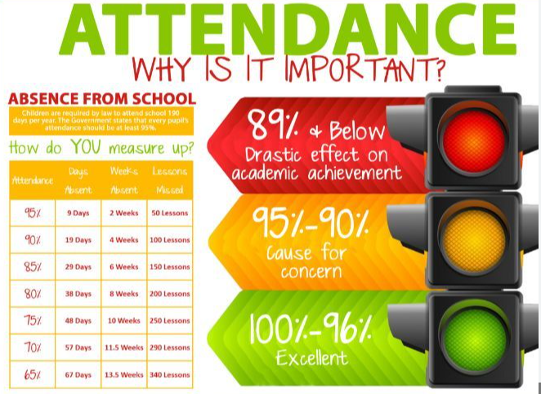
Attendance updates

As you know, the new national framework for penalty notices will come into effect from 19th August 2024 and will apply to all forms of unauthorised absence from school, including unauthorised holidays during term time.
Following my previous letter to you, I am now writing to inform you that the consultation regarding the local code of conduct for penalty notices has been completed and I have attached a copy of the new code for your information.

Parents who have booked holidays in prior to 19th August 2024 for which an absence request form has not been completed or where they have already been informed the absence is unauthorised, will be subject to the new increased fine amount if they choose to continue to take their child out of school. Please ensure that parent’s submitting requests now for next academic year are made aware of this.

Have a wonderful summer everyone,

Mr Moore.

Advice and Support

Dates for your diary  Tuesday 3rd September- INSET day- school closed for children.  Wednesday 4th September - Children return to school.  Friday 25th October - Last day of term  Monday 28th October -Half Term- School closed for children.  Monday 4th November -Non pupil day - School closed for the children  Tuesday 5th November - Children return to school  Friday 20th December - Last day of term  Monday 23rd December - Half Term - School closed for children  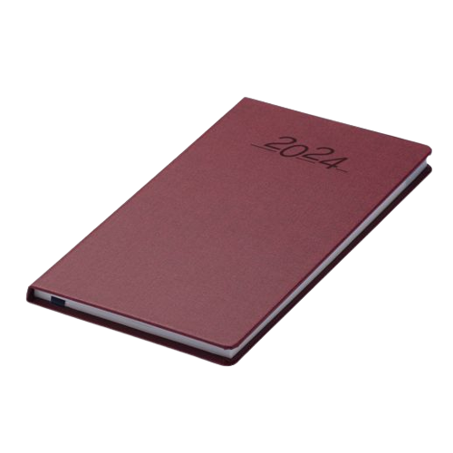 |  |   The uniform store Plymouth is a free service for families to kit out their children for school.  Through donations of good quality school uniform, we give the items to those in need, free of charge.  Our service is open to anyone to use- no referral is needed.  We are located at;  93 New George Street, Plymouth City Centre, PL1 1RQ  Opening hours:  Tuesday, Wednesday and Friday 10am-1pm.  Plymouth Uniform store


Is your child eligible for free school meals?

If you receive certain benefits then your child may be entitled to a free school meal and if so, their school receives extra funding. This means it’s important to apply, even if your child is in reception, year 1 or year 2 and already receives a free lunch.

Check the criteria and apply online: Free School Meals Plymouth

FOOD REQUEST

The Cathedral School of St Mary

have teamed up with

Love in action group -

The Cathedral Church of St Mary and St Boniface


If you email Marianne our School PSA, by Tuesday 2pm of the week you require help with food, you will be able to collect from School on The Wednesday/Thursday

t.cook@plymouthcast.com

