Mrs Wright’s Update!

Dear Parents, Carers and Pupils,
As we reach the midpoint of the academic year and prepare to enjoy a well- deserved break, I am delighted to share some updates and highlights from our vibrant school community. Celebrating Achievements: It has been a short but very busy half term for our School of Joy. In early January our KS2 pupils had a morning with Chris Lubbe, former bodyguard and great friend to Nelson Mandela. His assembly was about his own inspirational journey, covering inequality, racism and social justice. The children listened intently and asked some insightful questions. In the afternoon our parents were invited to an afternoon with Chris so he could share his story. A special thank you to those parents who attended. Our year 4 pupils had a fantastic week at Nethercott Farm near Okehampton. The farm is owned by the author Michael Morpurgo. Our children were fantastic with their behaviour, attitude and manners. I thoroughly enjoyed reading Michael Morpurgo books to them before bed. Our CSOSM and St Joseph’s Indoor athletic KS2 team qualified earlier in the academic year and so took part in the final this half term. This means that they were in the top 8 schools in Plymouth for Indoor Athletics. We were all super proud of this amazing achievement. Our KS2 pupils completed their bikeability course and it was inspiring to watch some pupils ride a bike for the first time! The school raised the profile of positive mental health during Children’s Mental Health Week and this culminated in a Mufti day raising money for Livewell Mental Health. Two new members of staff have joined our school team this half term. A special newsletter welcome to Mrs Castledine and Mrs Mendoza who will be working in our EYFS class. I’m sure our whole school community will make them feel very welcome.
Nurturing Faith and Values: At the Cathedral School of St Mary our faith is the cornerstone of everything we do. Throughout this half term, we have deepened our understanding of Catholic values and teachings through prayer, reflection, and acts of service. Our students have embraced opportunities to deliver the weekly Liturgy. Parental Engagement and Support: Over the February break please encourage your children in years 4, 5 and 6 to continue to learn times tables up to 12 fluently and to speed. This will help them to understand and make rapid progress in the maths they are being taught. Please encourage all pupils to read at home for pleasure and enjoyment. They also love to have adults reading to them the odd time.We are grateful for the ongoing support and partnership with our parents and carers. Your involvement in your child’s education is invaluable, and we appreciate the time and effort you invest in their learning journey.
Looking Ahead: As we look ahead to the second half of the year, we do so with optimism, enthusiasm, and a sense of purpose. There are many exciting opportunities and challenges on the horizon. As a school community, we will all rise to the forthcoming challenges of KS2 SATs, Year 4 Statutory MTCs (Multiplication Tables Check), Phonics and our due Ofsted inspection. Thank you for your continued support and partnership. Wishing you all a restful and enjoyable half term break filled with love, laughter, and cherished moments with family and friends.
Take care, Mrs Wright ‘For nothing will be impossible with God’ Luke 1:37
Catholic Life and Events

Catholic Life  In January some of our staff and students attended a special international Mass at St Peter’s Church to celebrate Jubilee 2025: Pilgrims of Hope. The Holy Father decided that 2025 would be a jubilee year, something which happens every 25 years. The theme is ‘Pilgrims of Hope’ and is a year of hope for a world suffering the impacts of war, the ongoing effects of the pandemic and a climate crisis.    Throughout the year we will take part in a number of activities associated with this special year. The international Mass was a celebration of diversity and hope with pupils from the CAST schools bearing the flags of their home nations.  EYFS Mass  Our youngest pupils began attending Mass this half term and represented our school beautifully. They were respectful and made the most of their time in the cathedral supported by their year 6 buddies.  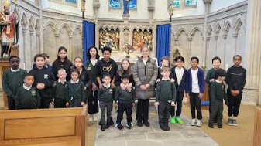 |  | Collective Worship  Regular events in St Joseph’s, Devonport  Exposition of the Blessed Sacrament  6:30pm-7:30pm Each Wednesday. Adoration prayer in both Polish and English.  Rosary group led by Polish people  Tuesdays at 6pm. All are welcome.  Polish Marian Children Group  Every other Sunday  Prayer in Polish.  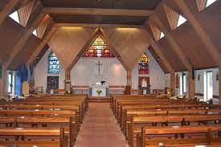  4pm every first Saturday of each month.  Regular events in The Cathedral Centre  Ecumenical Bible Study Group:  Thursdays -10.00am coffee/tea, 10.30-11.30am.  Legion of Mary:  Thursday, 6.00pm to 7.30pm  Union of Catholic Mothers:  Tuesdays 1.30pm-3.30pm.  St Pio Prayer Group:  On the first Friday of every month after 7.00pm Mass, all are welcome. Contact: Rev. Deacon Tony Irwin, Tel. 01548 853413.
Congratulations!

  We have high expectations for all of our pupils to arrive at school each day and on time. Thank you for your continued support.  The highest attendance this half term goes to…    Miss Galloghly’s class  As a ‘well done’ for winning this half term’s attendance, your class have earnt an extra 20 minutes playtime- keep up the excellent work! |  |   Heart of Gold Awards  Miss Grosch’s Class  The heart of gold this week goes to Kayden. He has been working really hard in our class, even when he finds something tricky. He has a brilliant attitude of never giving up. Well done Kayden. I am really proud of you!  Miss Galloghly’s Class-  The Heart of Gold winner is Dael- he has made such a lovely contribution to our classroom, and it has been amazing to see his work flourish as well as his personality. Well done for following our ready, respectful and safe rules at all times.  Miss Tom's Class-  The Heart of Gold award this week goes to Jeremiah. Jeremiah is an excellent role model setting high expectations, not only in the classroom, but throughout the school. He is always wanting to help others and nothing is ever too much trouble for him. You are a pleasure to teach Jeremiah. Keep up the good work.  Mrs Berry’s Class-  Jorcina is a pleasure to have in class. She is conscientious, determined and always has a positive attitude to her learning. Around the school, Jorcina is polite and shows kindness to everyone she meets. Keep up the good work Jorcina. Well done!
  Miss Grosch | 91.72%
  Miss Galloghly | 93.44%
  Mr Davies | 93.70%
  Mrs Berry | 90.45%

News and Events

Meet the Staff  Mrs Mendoza    I’m Mrs. Mendoza and I am part of the amazing team of EYFS/Year 1, led by Miss. Grosch, as a teaching assistant. I've lived in this beautiful city, Plymouth, since last year with my husband James and our son Matias. I am so happy to be part of your children's lives on their educational journey.  A little bit about myself: I am from Mexico and I speak Spanish as my first language. I graduated from LaSalle University in Mexico and I am currently studying a bachelor’s degree in psychology.  In my spare time I love to learn new things, go for long walks in nature with my friends and family and I also love to use my time to volunteer to support our community and make it a better place for our children. I have 3 years’ experience as an ESL teacher in Mexico - this will be my first year as a teaching assistant and I am hoping to make it my best year yet! | Meet the Staff  Mrs Castledine    I’m Mrs. Castledine, TA and I’m in Miss Grosch’s Class. I am very honoured to be part of this wonderful team and school within the community. My son attends this school and I have previously volunteered on many occasions on disco and summer fayre days.  I’m very passionate about our school as we are very diverse and believe in the catholic ethos. I myself have been brought up as a catholic. I’m originally from America and half Brazilian. I have previously worked in customer service careers and carework.  I am very happy to assist the children in their learning journey and making sure I provide the best as I can.  I am also a big fan of Argyle 🙂
We love to learn!

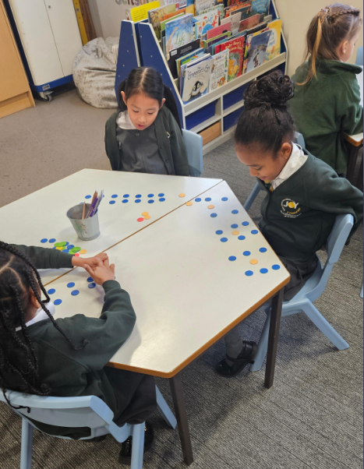 |  | 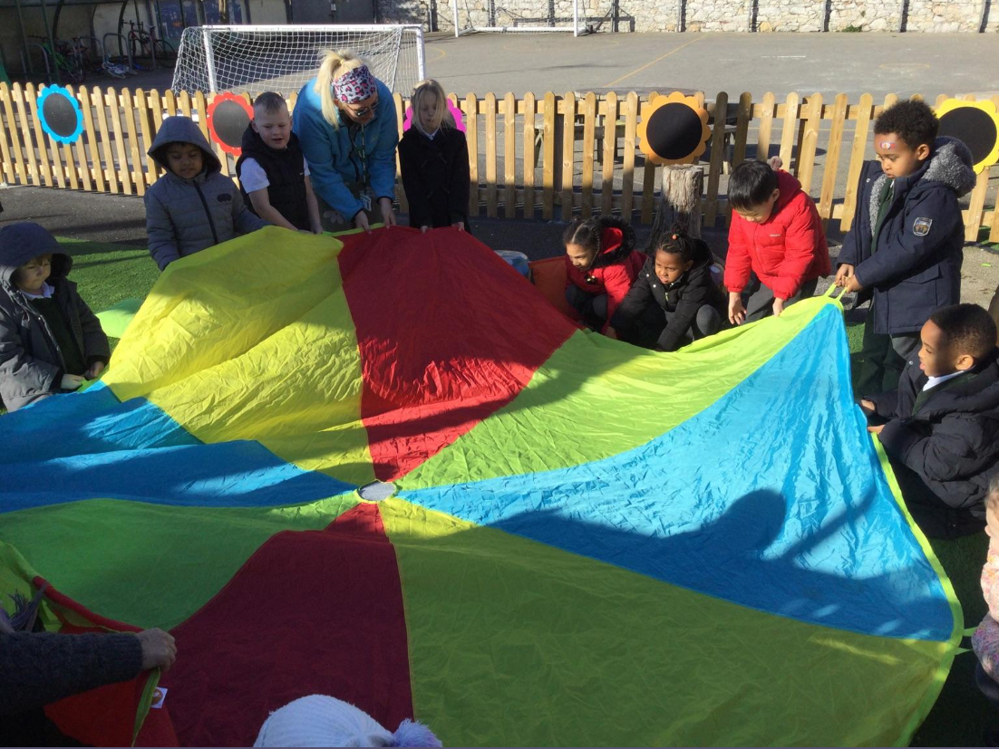
In Year 2, the children have enjoyed their maths. They used counters to show different arrays of multiplication and division sentences. |  | EYFS enjoyed reading a story called ‘The very big umbrella’. The umbrella welcomes everyone in so we used a parachute to make an umbrella.
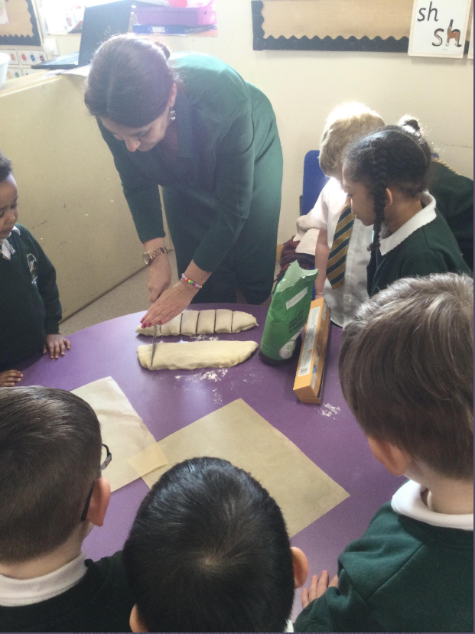 |  | 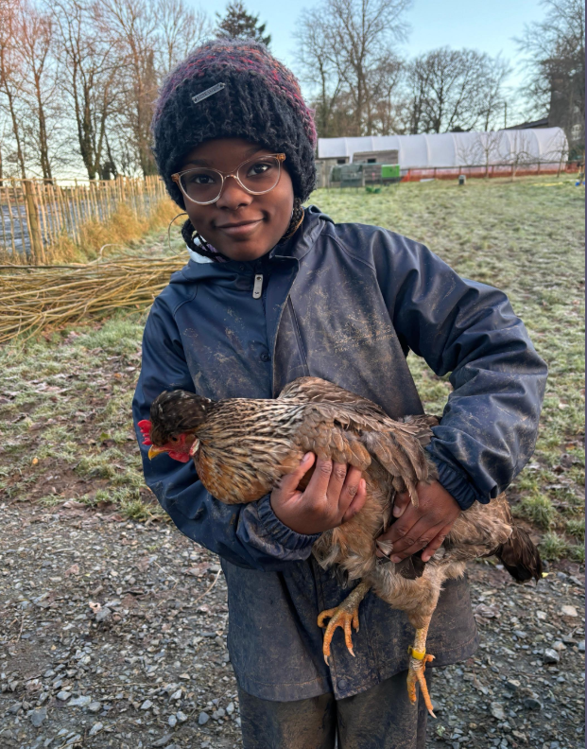
EYFS enjoyed learning about the story of how Jesus fed the 5,000. We made our own bread rolls and took them home. |  | Year 4 had a wonderful time on their residential- they enjoyed chicken handling, forest school and tasting herbs!
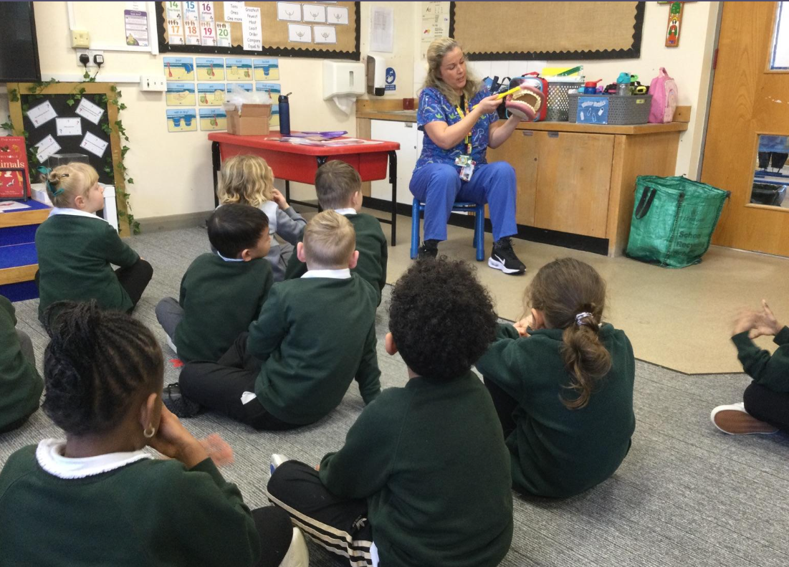 |  | 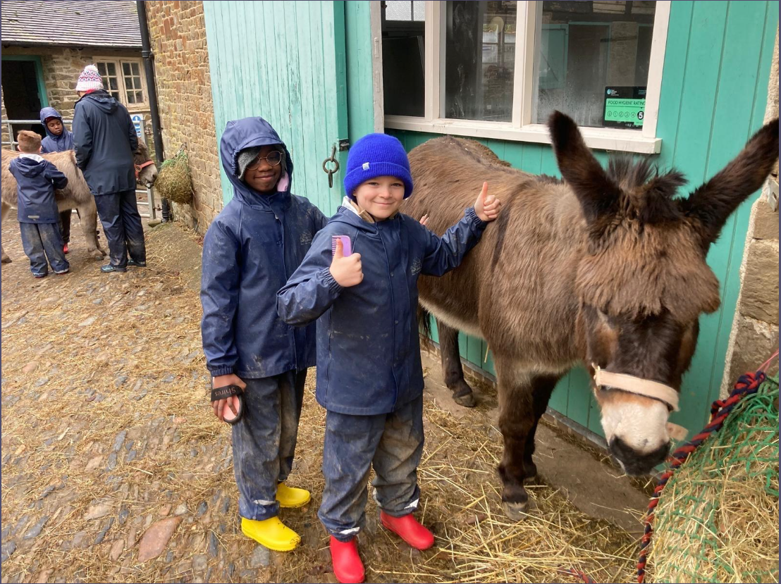
We had a visit from Laura who works for Plymouth Community Dental Team. We talked about cleaning our teeth and which foods can cause tooth damage. |  | The Year 4 residential enjoyed grooming the donkeys Applejack and Dexter.
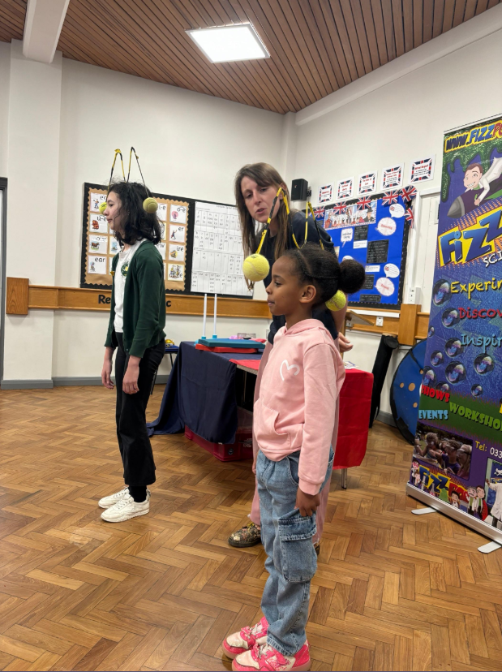 |  | 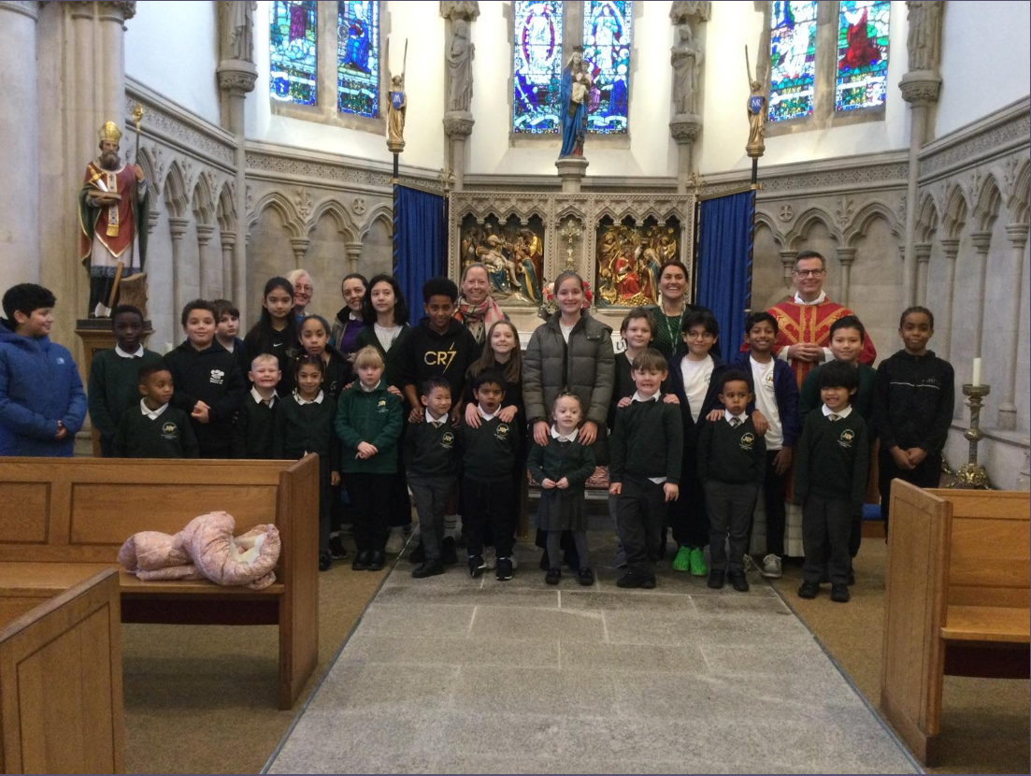
The children loved our Visit from Fizz Pop Science, especially when they saw Miss Toms on a hoverboard! |  | It was a lovely moment when the EYFS children attended Mass with their buddies for the first time. The children sat beautifully in the Cathedral and they were a credit to the school.

Half Term Events



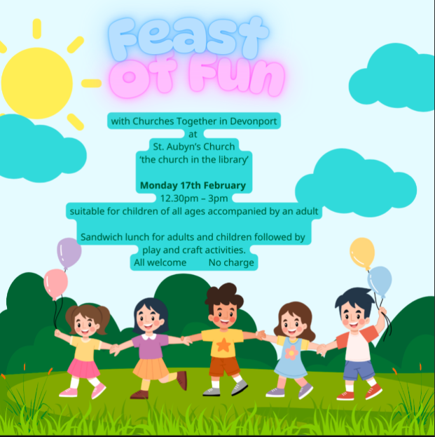


Advice and Support

We are Readers

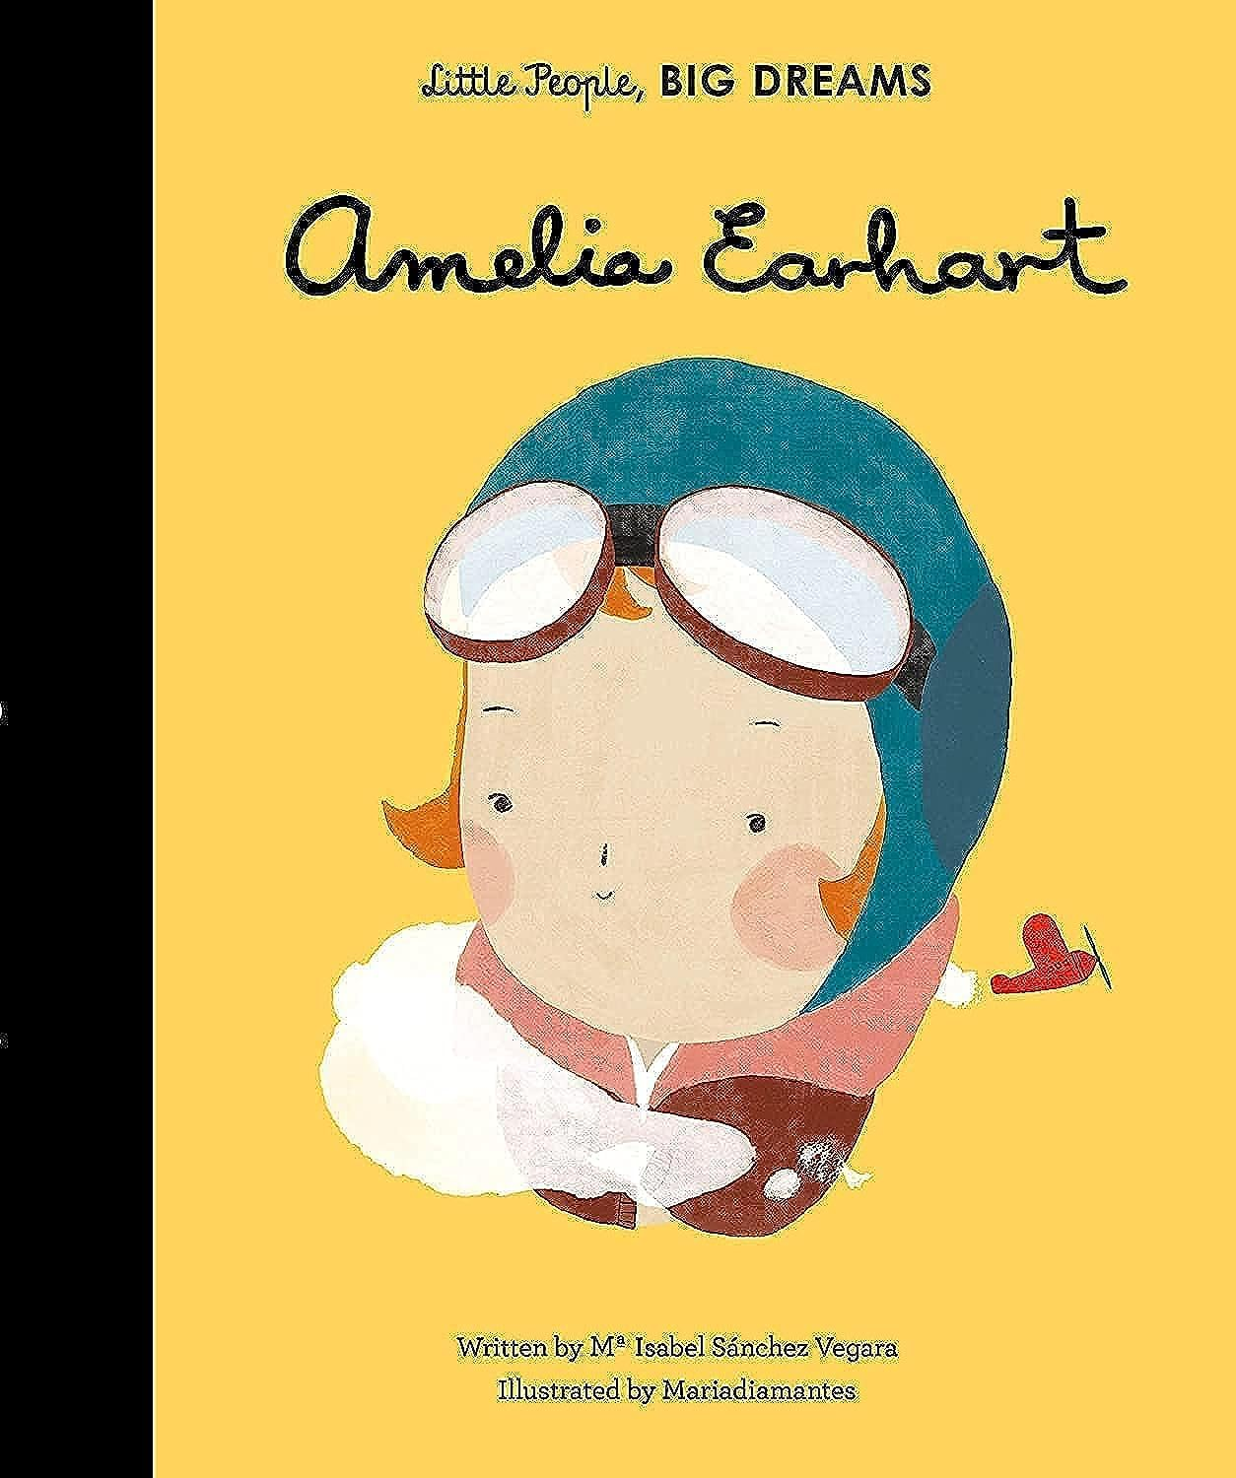

Miss Toms’ class have been looking at the book ‘Amelia Earhart’.
The children have enjoyed learning all about Amelia’s life and how she inspired many others to pursue their own love of things.
We looked at several different biographies including the style that they are written in, and after lots of planning, the children have produced their own amazing biographies about Queen Elizabeth II.
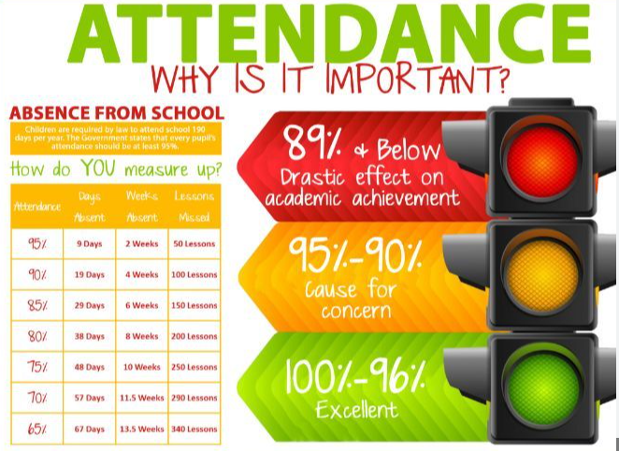
Attendance updates

Attendance this year continues to be in line with both the local authority and the national levels and as a school we should be incredibly proud of this! I want to say a huge ‘Thank you’ to all of our children and families with their support with attendance and we are now 1.2% better than this point last year.

However, one area we now need to focus on is persistent lateness. As a school, lateness continues to be a n area for improvement as many children are arriving after 8.55am. Please ensure that your children arrive by 8.55 as this is the tie when registration closes. If you have any concerns around your child’s attendance, please speak to Mr Moore or Mrs Wright.

Have a lovely half term everyone

Advice and Support

Dates for your diary  Monday 24th February - Non pupil day - School closed to pupils  Tuesday 25th February - Term commences- children back to school  Thursday 6th March - World Book Day  Friday 7th - Sunday 16th March - British Science Week  Thursday 20th March - School Photographs (Class photos only)  Friday 4th April - Last day of term  Monday 7th - Monday 21st April - Easter Half Term (School closed for 2 weeks)  Tuesday 22nd April - Term commences - children back to school  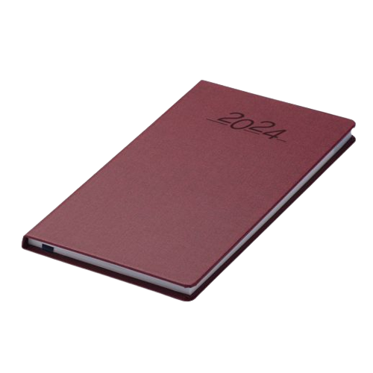 |  |   The uniform store Plymouth is a free service for families to kit out their children for school.  Through donations of good quality school uniform, we give the items to those in need, free of charge.  Our service is open to anyone to use- no referral is needed.  We are located at;  93 New George Street, Plymouth City Centre, PL1 1RQ  Opening hours:  Tuesday, Wednesday and Friday 10am-1pm.  Plymouth Uniform store


Is your child eligible for free school meals?

If you receive certain benefits then your child may be entitled to a free school meal and if so, their school receives extra funding. This means it’s important to apply, even if your child is in reception, year 1 or year 2 and already receives a free lunch.

Check the criteria and apply online: Free School Meals Plymouth

FOOD REQUEST

The Cathedral School of St Mary

have teamed up with

Love in action group -

The Cathedral Church of St Mary and St Boniface


If you email Marianne our School PSA, by Tuesday 2pm of the week you require help with food, you will be able to collect from School on The Wednesday/Thursday

t.cook@plymouthcast.com#

